TITLE:
Incidental Aberrant Right Subclavian Artery (ARSA) In Adults: Can Computed Tomography (CT) Imaging Features Predict Development Of Late Onset Dysphagia?
PURPOSE:
To evaluate the role of CT in the diagnosis of ARSA and to assess the role of CT morphometric features including size, angle and atherosclerosis in predicting development of late onset dysphagia lusoria.
METHODS:
A total of 38 patients with ARSA were evaluated. 9 patients were excluded based on age <18 years and associated diseases causing dysphagia. CT features including size, angle of take off and the presence or absence of atherosclerosis were assessed using curved Multiplanar Reformation (MPR) images. Any difference in the size and angle between patients with and those without difficulty in swallowing was sought. Patients were followed over a mean period of 18 months for need of surgery.
RESULTS:
Most of the patients were females (n=17 59%). Dysphagia was present in 6 (20%) of patients with ARSA while the remaining 80% had no swallowing difficulty. The mean size and take off angle of ARSA in patients with some degree of dysphagia was 11.4 ± 1.5 mm and 62.9 ± 3.4 degrees while in those with no history of difficulty in swallowing was 9.4 ± 1.3 mm and 81 ± 8.1 degrees respectively. Atherosclerosis of ARSA was seen in 13 (45%) of our patients which included 5 (17%) patients with dysphagia, 2 (7%) patients with aortic dissection and 6 (21%) patients with no symptoms related to ARSA.

CONCLUSION:
CT scan is the gold standard for diagnosis of ARSA. CT morphometric features (size, angle and atherosclerosis) can give a suggestion of future development of dysphagia and can help earmark patients which require follow up. Most cases of dysphagia lusoria respond to conservative management.
KEYWORDS: ARSA Aberrant Right Subclavian Artery, CT Computed Tomography, Dysphagia Lusoria.

Introduction
Aberrant right subclavian artery (ARSA) also called the lusorian artery is rare anomaly of the right subclavian artery. It is formed as a result of abnormal involution or absence of right fourth aortic arch ^{[1]}. The artery crosses the midline between the esophagus and the vertebral column in most cases and sometimes has a bulbous dilatation at its origin called the kommerells diverticulum ^{[2]}. Sometimes the course can be between the trachea and the esophagus or rarely anterior to the esophagus. A closely associated but rarer anomaly is the right aortic arch with aberrant left subclavian artery (ALSA) ^{[3]}. Although usually asymptomatic and incidentally detected on computed tomography, it can sometimes lead to esophageal compression with dysphagia as the presenting symptom and has been named as dysphagia lusoria ^{[4]}. In children the ARSA can even cause compression of the trachea leading to dyspnea. A few cases of ARSA associated with aortic dissection have also been reported ^{[5, 6]}.With the advent of cross sectional imaging including CT and MRI, ARSA is encountered quite commonly as an incidental finding. Most of these aberrant arteries are asymptomatic requiring no intervention. There have been researches to determine any morphological feature (size and angle) that could predict the likelihood of dysphagia in incidentally detected ARSA; however no significant correlation was found ^{[7]}.
Our study was aimed at analyzing the morphological features of ARSA on CT and their association with complications including dysphagia and dissection. The identification of features more likely to lead to complications can help follow these patients closely and earmark the aberrant vessels that might require treatment in the form of surgery.

Methods
We conducted a retrospective study wherein CT images where obtained from the archive and were then assessed for the presence of ARSA. We evaluated a total of 2200 CT scans and found 38 patients with ARSA who were included in the study. All patients below 18 years of age, those with poor quality images and other associated conditions that could lead to dysphagia were excluded. 7 patients among the 38 were excluded owing to the presence of esophageal and gastro-esophageal junction tumors while two were below 18 years of age.
Clinical profile:
The demographic profile and clinical details were obtained from the medical records department. The indication for the CT scan as well as any history of difficulty in swallowing was specifically sought. The presence of any disease including autoimmune diseases or esophageal dysmotility was also sought.
Computed Tomography:
All patients were examined with a multi–detector row CT scanner (CT 64 SOMATOM) using 1.5-2 ml/kg of non-ionic intravenous contrast agent (Omnipaque / Contrapaque 300mg/ml) through an 18-gauge antecubital intravenous line at a rate of 3 mL/sec wherever necessary. Scans were obtained with 1.0-mm slice thickness and 1.0-mm reconstruction interval from the lung apex to level of the adrenals. The scans were transferred to a dedicated work station where they were evaluated by two radiologists who were kept blinded to the symptoms of the patients. A calculation of the size of the ARSA at the level where it crosses the esophagus was measured and recorded. We also calculated the take off angle of ARSA as the angle between the long axis of the arch of aorta and the long axis of the ARSA. The final measurements were the mean of the two measurements taken by the two radiologists. Curved MPR images were used to calculate the angle in axial images. The presence of any atherosclerotic change in the ARSA was also noted. CT scans were also evaluated for any esophageal or GE junction thickening, esophageal dilatation, any stricture or diverticulae as well as any associated pathology.
The data was collected and evaluated using SPSS 21.0. Descriptive data was analyzed by frequencies and categorical data by percentages and continuous variables by means and standard deviations. Continuous variables were compared using Student’s t test. For all comparisons, p-value of <0.05 was considered statistically significant

Results
Patient profile:
We evaluated a total of 29 patients with ARSA having a male to female ratio of 12 (41%): 17 (59%). The mean age of the patients was 47.3 ± 10.4 years (range 30-69 years).
Clinical profile:
Majority (n=27 93%) of our patients had undergone CT scan for reasons other than dysphagia including chest pain, suspected thoracic infections, metastatic work up and trauma. Two (7%) of our patients presented with dysphagia and were imaged with CT after other investigations including endoscopy and barium swallow were unremarkable.
Dysphagia including any difficulty in swallowing was present in 6 (20%) of patients with ARSA in our study while the remaining 80% had no swallowing difficulty.
Computed Tomography findings:
All our patients had a left sided aortic arch with aberrant right subclavian artery arising as the final branch of the arch. The mean size of ARSA in our study was 9.8 ± 1.5 mm. The mean size of ARSA in patients with some degree of dysphagia was 11.4 ± 1.5 mm while in those with no history of difficulty in swallowing was 9.4 ± 1.3 mm.
The mean take off angle of ARSA from the aorta was 77.6 ± 9.5 degrees. Mean angle in those with dysphagia was 62.9 ± 3.4 degrees while the mean angle in patients with no such complaint was 81 ± 8.1 degrees.
Atherosclerosis of ARSA was seen in 13 (45%) of our patients which included 5 (17%) patients with dysphagia, 2 (7%) patients with aortic dissection and 6 (21%) patients with no symptoms related to ARSA.
We had two (7%) patients with ARSA and aortic dissection. Both of these patients were hypertensive and had atherosclerotic changes involving the aorta as well as the ARSA. The mean size and mean take off angle in these two patients was 11.5 mm and 66 degrees respectively.
Follow up:
All the patients were on follow up for a mean time of 18 months. Those without any symptoms remained symptom free while those who had some difficulty in swallowing were all managed medically with none requiring surgical intervention. Among the two patients with aortic dissection, one expired due to extensive dissection involving the mesenteric arteries and ARSA while the other patient was managed conservatively and is doing well.

Discussion
We conducted a study at our institute including 29 patients with aberrant right subclavian arteries (ARSA) with the aim of deducing any morphological feature on CT of these patients that can help predict the development of dysphagia in these patients. We evaluated a total of 2200 CT scans and found an overall incidence of ARSA to be 1.7% (n=38). This incidence is quite similar to previous studies in which the incidence ranged from 0.6-2% including the studies of Jannsen et al ^{[1]}, Fockens et al ^{[8]} and Atanasova et al ^{[9]}. The slightly higher incidence in our study is probably due to the use of CT scan as a diagnostic tool as opposed to endoscopy or barium studies.
Among the 38 patients 7 were excluded in view of the presence of esophageal and gastro-esophageal junction tumors to remove any bias with regard to dysphagia. Two other patients were excluded owing to their ages being less than 18 years as we were assessing late onset dysphagia in ARSA patients. Among the 29 patients we evaluated, females were affected more (59%) than males (41 %). We had patients ranging in age from 30 – 69 years. These demographic profiles are concordant with previous studies including those of Alper et al ^{[7]} and Ramesh Babu et al ^{[10]} who in their studies also found a female predominance in the incidence of ARSA.
Most of the patients with ARSA had undergone CT scan for reasons other than dysphagia including chest pain (n=5), trauma (n=4), metastatic work up (n=4) and suspected infection (n=14) including those with COVID -19. Only two patients underwent CT for dysphagia when endoscopy and barium studies were negative. Among the 29 patients 6 (20%) patients developed dysphagia over a period of 18 month follow up including two at presentation and 4 during the follow up period. This finding is quite similar to those of Jansenn et al ^{[1]} and Alpers et al ^{[7]} who in their studies found a 20-40% of patients with ARSA to be symptomatic for varying degrees of dysphagia. The reason for adult onset dysphagia has been evaluated in the past and the likely reasons put forth include increasing rigidity of the esophagus or the vessel with age, presence of Kommerell’s diverticulum, tortuosity of the aorta or a truncus bicaroticus accompanying ARSA ^{[11-13]}.
The average size of ARSA in patients with dysphagia was 11.4 ± 1.5 mm in comparison to those with no swallowing difficulties 9.4 ± 1.3 mm. Although the difference in size was not statistically significant (p > 0.1), the mean size was greater in symptomatic patients than in those with no symptoms. The size of the artery in a previous study done by Alpers et al was 16.4±4.3 mm which is more than our study. The difference is probably due to the method and the location of measurement of the artery. In our study we measured the size of the artery at the point where it crosses the esophagus while in the previous study the specific location has not been mentioned. This shows that with increasing diameter of the ARSA the chances of dysphagia are more, however size alone cannot determine the development of dysphagia as there were many patients with increased size (>12 mm) but had no difficulty in swallowing.
The take off angle of the vessel has been used in the diagnosis of vascular compression syndromes including Willkie’s syndrome, however very few studies have evaluated the angle of take off in case of ARSA and its association with esophageal compression and dysphagia. In our study we found the mean take off angle of ARSA in patients with difficulty in swallowing was 62.9 ± 3.4 degrees while the angle in asymptomatic patients was 81 ± 8.1 degrees. Overall the mean angle of take off was 77.6 ± 9.5 degrees. The difference in the take off angle between those with and those without dysphagia was statistically significant. However there was some degree of overlap in the take off angle and in view of the small sample size ROC curve and a definite threshold couldn’t be calculated. Alpers et al ^{[7]} in their study found an angle of 48.8±10.7 degrees in their patients with ARSA and associated dysphagia lusoria. The difference in the angle between our study and Alpers et al is probably due to the method of measurement. We measured the angle between the long axis of the aorta and the long axis of the ARSA at the level where it crosses behind the esophagus while the method has not been clearly demonstrated in the study by Alpers et al. We also observed the presence of atherosclerosis in all but one patient with dysphagia, however atherosclerotic plaques were also seen in 8 patients with no difficulty in swallowing. These patients with plaques but no dysphagia however had wider angles of take off and smaller artery sizes. We therefore believe that CT evaluation for dysphagia secondary to vascular compression is not only a gold standard for diagnosis but can also serve as a predictor for development of late onset dysphagia lusoria. Adult dysphagia lusoria is a rare entity with no definite predictors for its occurrence. However our study suggests morphological features including size of the aberrant subclavian artery, take off angle and the presence of atherosclerosis that can serve as predictors of adult onset dysphagia in patients with ARSA especially when all three factors are combined.
All the patients in our study with dysphagia were managed conservatively with prokinetic and antireflux drugs. All but one responded to conservative management. The one patient which continued with the symptoms was the one with the narrowest angle of take off (57 degrees) was offered surgery but he refused the same. We therefore suggest that a larger study should be conducted wherein the morphological features on CT should be correlated with presence and severity of dysphagia as well as the need for surgical intervention.
The limitations of our study included relatively small set of patients although the number is comparable to many previous studies. Secondly, although barium esophagogram and endoscopy were used to rule out any intrinsic pathology, esophageal manometry was not done in all patients to rule out some occult cause of dysphagia.

Conclusion
ARSA and its association with dysphagia in adults is very rare. CT can serve as a gold standard for diagnosis of ARSA. CT morphometric characteristics including size of the artery, angle of take off and the presence of atherosclerosis combined together can serve as robust means of predicting the occurrence of dysphagia. Association of aortic dissection with ARSA needs further evaluation.

Bibliography

- Janssen M, Baggen MG, Veen HF, Smout AJ, Bekkers JA, Jonkman JG, et al. Dysphagia lusoria: clinical aspects, manometric findings, diagnosis, and therapy. Am J Gastroenterol. 2000; 95(6):1411–6.
- Kommerell B. Verlagerung desO¨ sophagus durch eine abnorm verlaufende Arteria Sublavia Dextra (Arteria Lusoria).Fortschr Geb Roentgenstr Nuklearmed 1936; 54:590 –5.
- McNally PR, Rak KM. Dysphagia lusoria caused by persistent right aortic arch with aberrant left subclavian artery and diverticulum of Kommerell. Dig Dis Sci 1992; 37:144–9.
- Whitley A. Dysphagia lusoria: a case study. J Vasc Nurs 2001; 19:14–7.
- S. Kawamoto, D.A. Bluemke, E.K. Fishman.Aortic dissection involving an aberrant right subclavian artery: CT and MRI findings J Comput Assist Tomogr, 22 (1998), pp. 918-921
- Qing-Le Li, Xiao-Ming Zhang, Xue-Min Zhang. Aortic dissection originating from an aberrant right subclavian artery. Journal of Vascular Surgery, Volume 46, Issue 6, 2007, Pages 1270-1273.https://doi.org/10.1016/j.jvs.2007.06.042.
- Alper F, Akgun M, Kantarci M et al. Demonstration of vascular abnormalities compressing esophagus by MDCT: special focus on dysphagia lusoria. Eur J Radiol. 2006; 59(1):82–7.
- Fockens P, Kisman K, Tytgat GNJ. Endosonographic imaging of an aberrant right subclavian (lusorian) artery. Gastrointest Endosc 1996; 43:419.
- Atanasova D, Markov D, Pavlova E. [ABERRANT RIGHT SUBCLAVIAN ARTERY (ARSA)--A NEW ULTRASOUND MARKER FOR CHROMOSOMAL FETAL ABNORMALITIES]. Akush Ginekol (Sofiia). 2015; 54(4):12-7. Bulgarian. PMID: 26410943.
- Ramesh Babu CS, Gupta O, Kumar A. Aberrant right subclavian artery: A multi-detector computed tomography study. J. Anat. Soc. India, 2021.
- Brown DL, Chapman WC, Edwards WH, et al. Dysphagia lusoria: Aberrant right subclavian artery with a Kommerell’s diverticulum. Am Surg 1993; 59:582– 6.
- Klinkhamer AC. Het vaststellen van aberrante arterien in het mediastinum superius door middel van oesophagogram. Thesis, Leyden 1–187, 1962.
- Klinkhamer AC. Aberrant right subclavian artery; clinical and roentgenological aspects. Am J Roentgenol 1966;97:438–6.

Figures with legends
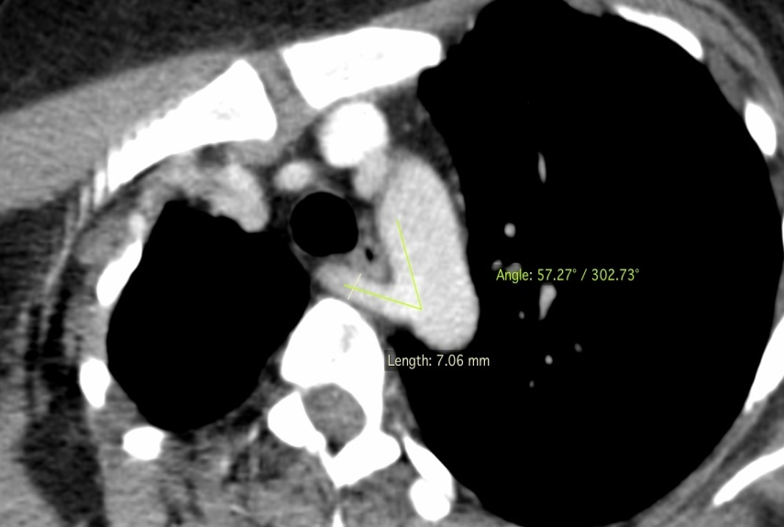
b
a
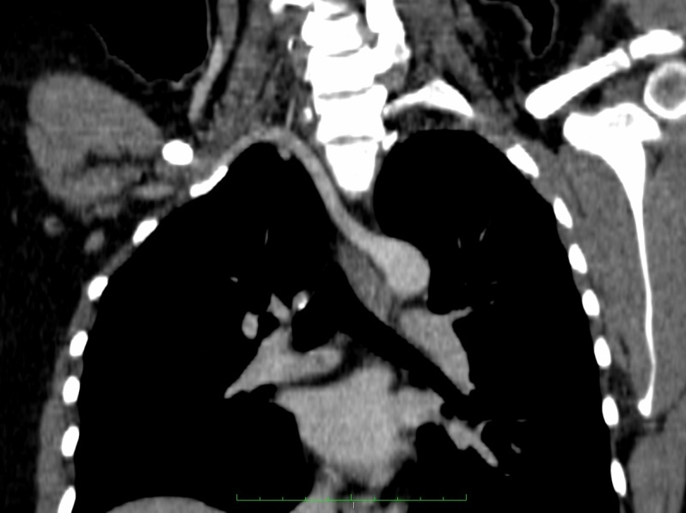
c
Figure 1: Axial contrast MPR images (a,b) of a female patient presenting as dysphagia showing narrow angle of take off (57 degree) and a small size (7mm) of ARSA. No atherosclerosis was observed. Coronal MPR image (c) showing the ARSA extending across midline to right side.

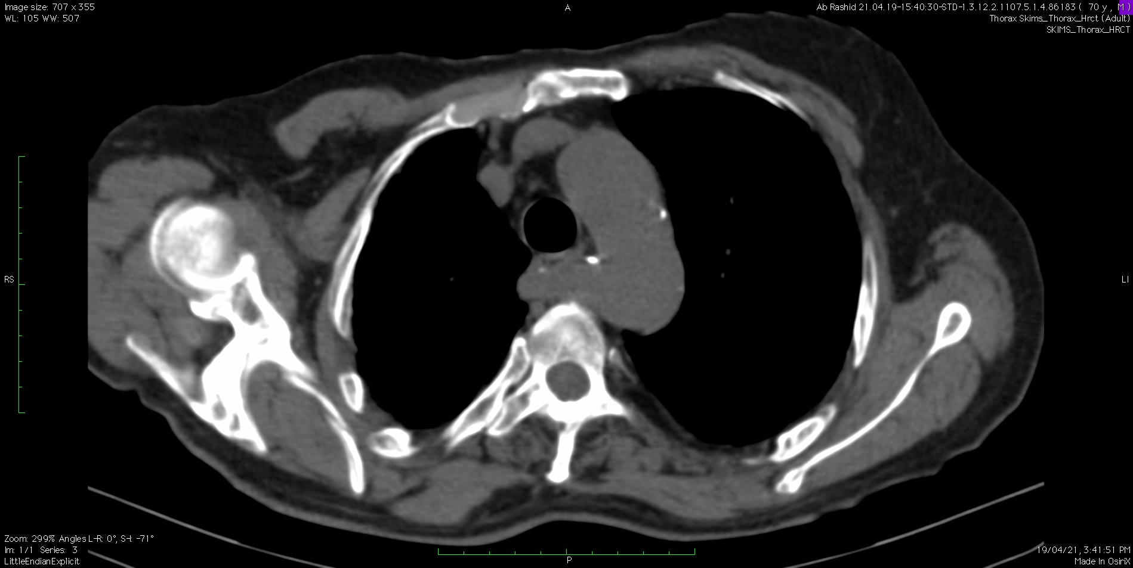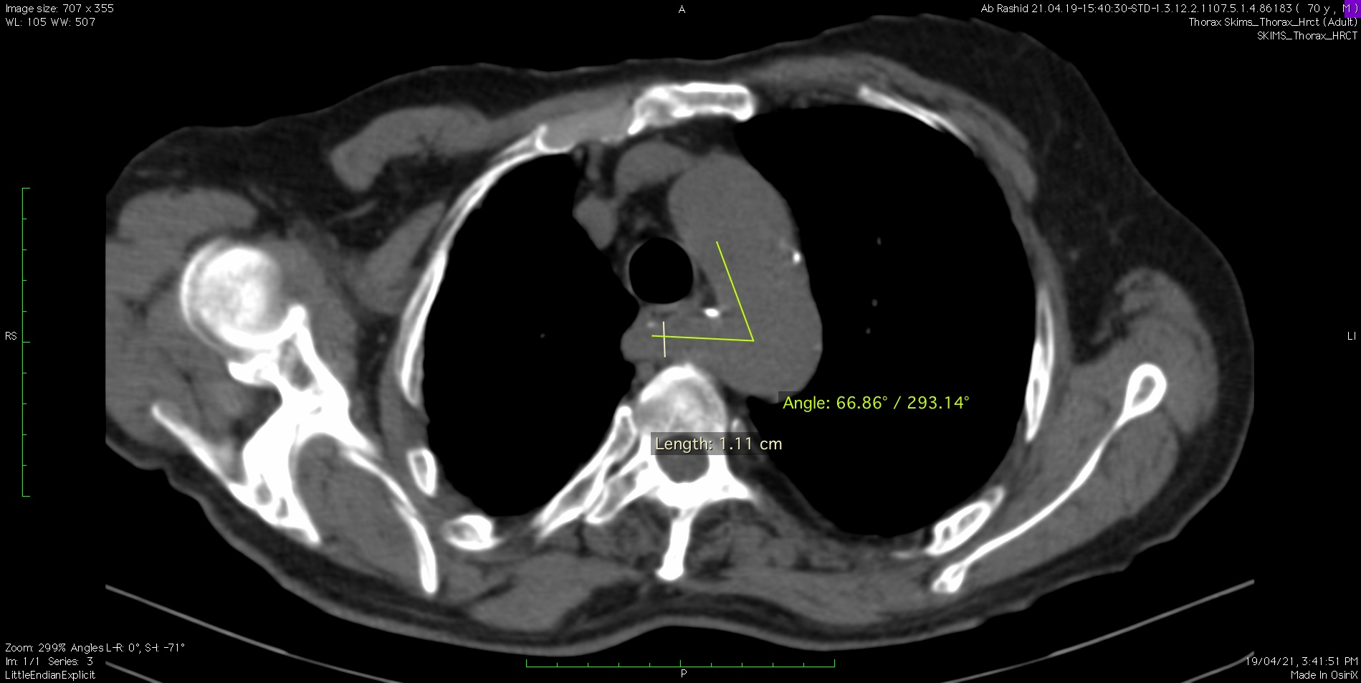
b
a
Figure 2. Non contrast axial images at the level of the aortic arch showing the ARSA with calcified plaque having a size of 11 mm and a takeoff angle of 67 degrees. This patient developed mild dysphagia during the follow up period.

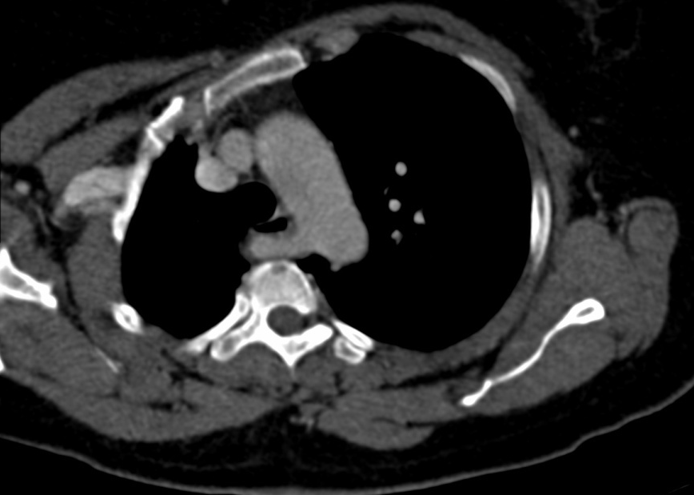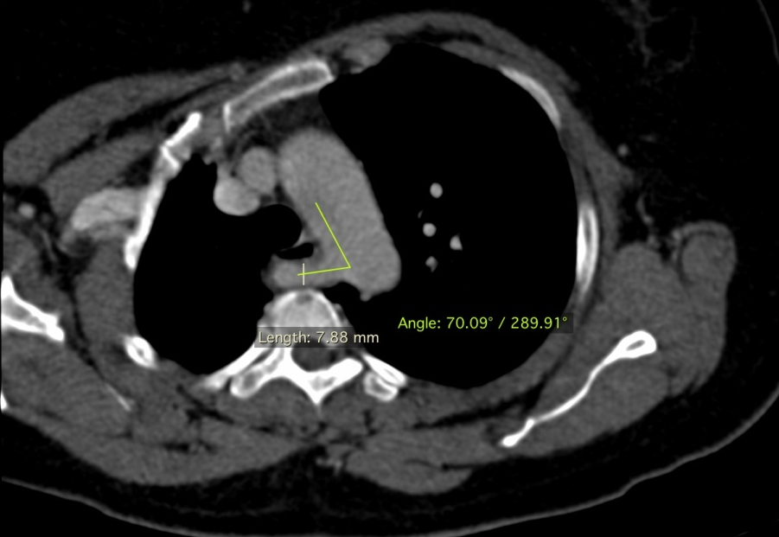
b
c
a
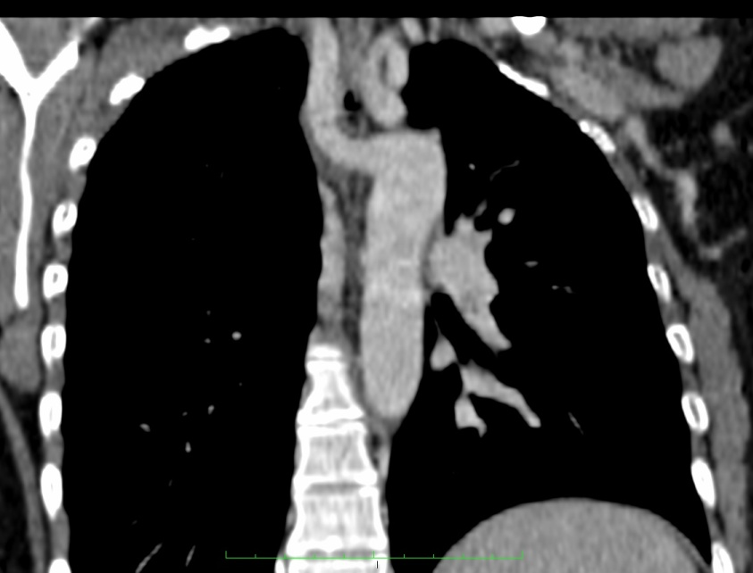
Figure 3. Axial contrast enhanced curve MPR images (a,b) showing an ARSA with a wide take off angle of 70 degrees in a patient with no complaint of any difficulty of swallowing. Coronal (c) reveals the ARSA extending across the midline posterior to the esophagus.

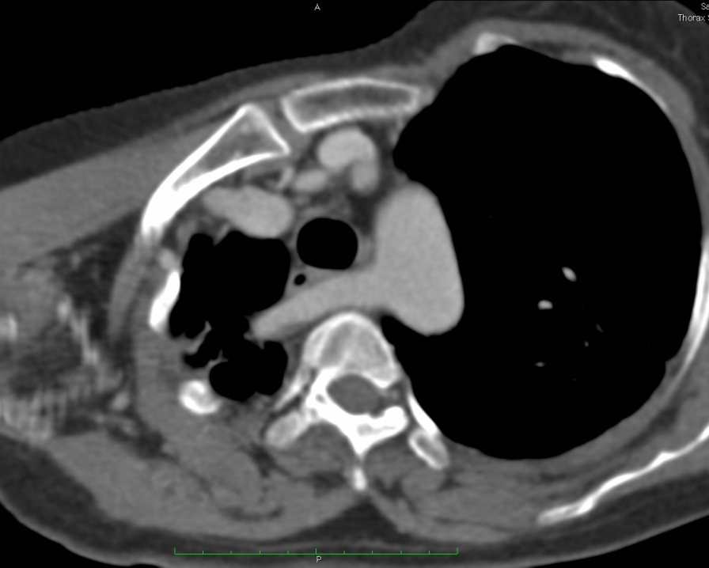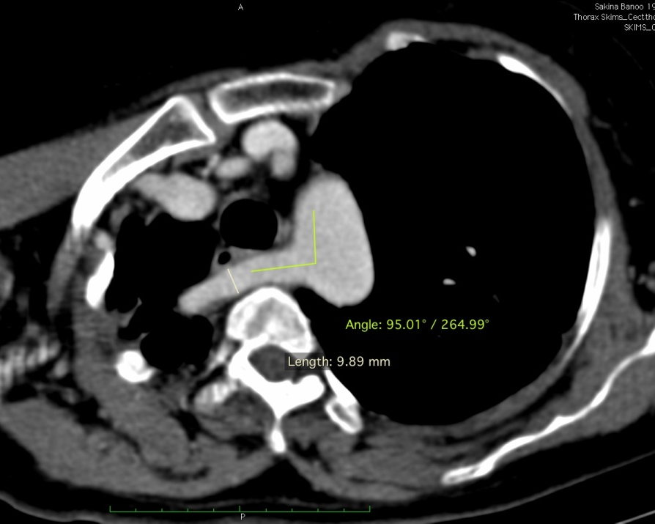
a
b

Figure 4. Axial contrast enhanced curved MPR images (a,b) in 50 year old male showing ARSA with takeoff angle of 95 degrees and size of 10 mm. The patient had no difficulty swallowing in the follow up period.

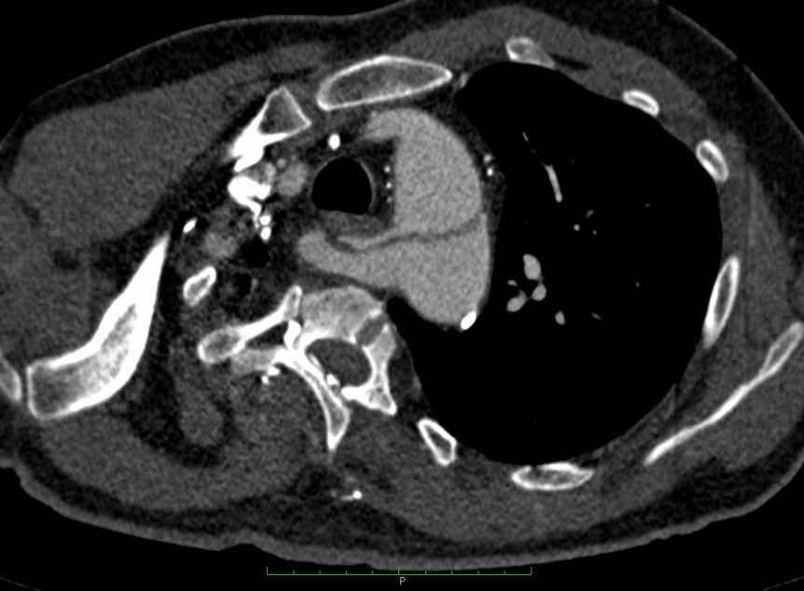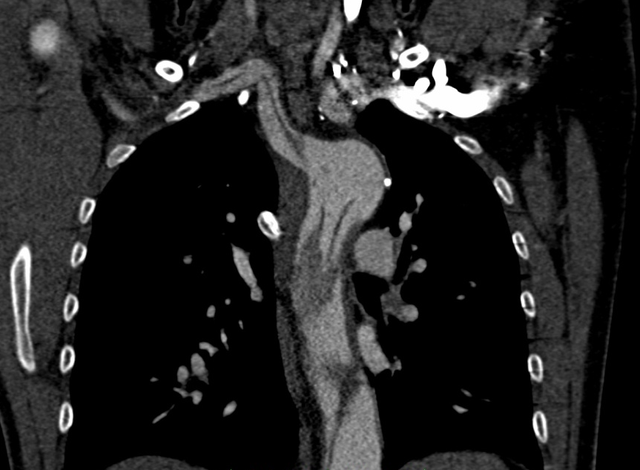
a
b
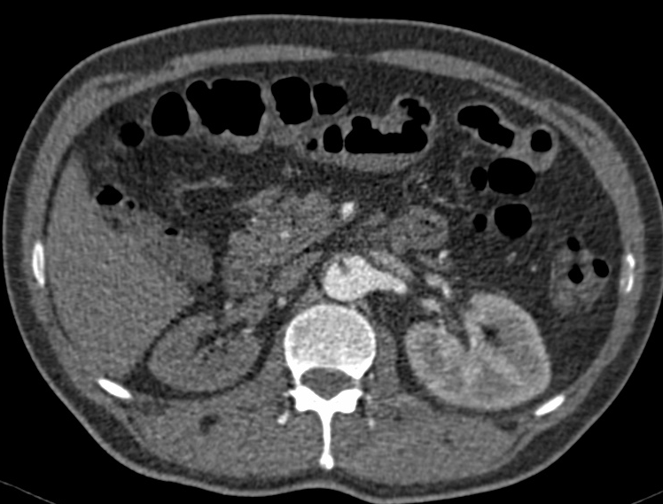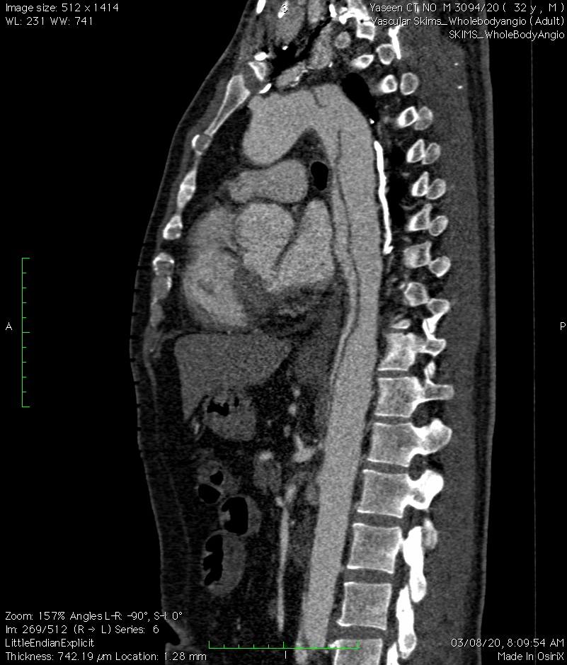
d
c
d
c
Figure 5. Contrast enhanced axial (a) and coronal (b) images showing ARSA with an angle of 79 degrees and presence of aortic dissection flap extending into the ARSA. Axial (a) and sagittal (b) contrast enhanced images showing the inferior extent of the dissection and non enhancement of right kidney indicating extension of dissection into right renal artery.

