WATER RESOURCES MANAGEMENT AND ITS EXPLOITATION STRATEGY IN ALGERIA: THE CASE OF THE WILAYA OF SAIDA
Oumria MIMOUNI ^{1,2}, Moussa LESGAA^{1,2}
- University of Oran 2, Faculty of Earth Sciences and Universe, Department of Geography, Oran – Algeria.
- Laboratory EGEAT Geographic Space and Territorial Planning Cité des chercheurs (Ex. IAP). Es-Sénia - Oran– Algeria.
* Corresponding author. Email: m_oumer2002@yahoo.fr
Abstract
Water is a vital resource and a limiting factor for economic development, water stress and scarcity of this natural resource due to several factors such as climate change, population growth and economic development. The exploitation of these resources is very intense with the growing needs. Water resources are under pressure day by day and faced with the challenge of preserving this resource, a water management policy has been implemented in the field of water resource mobilisation, drinking water distribution, wastewater treatment, desalination of sea water and protection of water resources. To this end, more reliable information is needed on the quantity and quality of water available in the Western Highlands region and how this availability varies over time and from place to place, as knowledge of water resources is a prerequisite for good sustainable management.
Keywords: Climate; Desalination; Management; Stress; Wastewater; Water.
INTRODUCTION
Water Resources Management is the process of planning, developing, and managing water resources across all water applications, in terms of both quantity and quality. Water management is supported and guided by institutions, infrastructure, incentives, and information systems (Xie, 2006). Water plays an important part in many facets of human activity, hence sustainable management of water resources is critical for society's progress. Domestic, commercial, industrial, agricultural, and recreational uses all require water (Ngene et al. 2021). All industrialized countries have a long history of investing heavily on water infrastructure, institutions, and the capacity to effectively manage water resources (Nguyen et al. 2019). While less developed countries, on the other hand, are characterized by a lack of water infrastructure, weak institutions, and poor water governance (Olagunju et al. 2019). Algeria is establishing a national water plan to safeguard its water resources and give a long-term solution to water supply and management issues. This program is consistent with the Algerian government's efforts to improve the functioning of the country's water sector. Desalination for coastal towns, medium-sized dams to irrigate the interior mountains and highlands, and ambitious water transfer projects joining Algeria's 65 dams to send water to water-scarce portions of the country are all part of the water plan. Technologies for wastewater treatment and water recovery are also in high demand. The fundamental goal of the country's water policy is to ensure that the population has enough drinking water. This is accomplished through increasing the quantity and availability of water resources (Drouiche et al. 2012). Because of its geographical location and natural resources (agricultural and mineral water), the groundwater of the Saida is a vital resource for the entire region of north-western Algeria. At the primary source's discharge, this groundwater is subjected to qualitative and quantitative monitoring. Due to overexploitation of water and excessive use of agricultural fertilisers, groundwater is currently suffering from substantial deterioration (Bentabet et al. 2019). The wilaya of Saida, like the wilayas of Algeria's western high plains, has experienced a severe dearth of drinking water as a result of population growth, socioeconomic development, and the expansion of agricultural and pastoral operations. Water supplies are insufficient to fulfill needs and expanding demands, and the wilaya of Saida is unable to cope with the water shortage. It is in this context that the management bodies have appealed for water to be transferred from the Chott Chergui aquifer. This water is used along a length of 100 km to offset the shortfall observed over the last decades in order to safeguard the mineral water table of Saida and improve the supply of drinking water. The mobilized resources total 97,559 million dollars, and water use is split around 40 percent between population supply and irrigation (60 %). Between the availability of resources and the demand for them? Is Ain Skhouna's water up to snuff in terms of quality, and can it meet the population's demands?
MATERIALS AND METHODS
Presentation of the study area
According to map N 1 the wilaya of Saida is located in the west of Algeria, it occupies a central position in the Oranie, it is part of the high western plains. This wilaya borders the wilayas of Mascara in the North, Sidi Bel Abbés in the West, Tiaret in the East and El Bayadh in the South. It covers an area of 6,765.4 km2 and has 16 communes grouped into 6 daïras. The wilaya belongs to the Mediterranean bioclimatic stage, semi-arid in a general way it is characterized by a cold climate in winter, dry and hot in summer. The geographical and geological make-up of the wilaya distinguishes two distinct geographical areas, the high steppe plains in the south and the Atlas mountains in the north (Tlemcen, Dhaya and Saida mountain ranges).
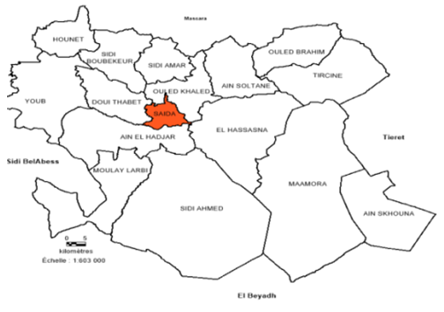
Map 1. Geographical location of the wilaya of Saïda
Socio-economic framework
In 2008, 75.28% of the wilaya's population was concentrated in the main towns, 12.26% in the secondary towns and 12.44% in sparse areas. Estimates for 2012 put the population of the Saida region at 384200 inhabitants and an average annual growth rate of 2.49%.
The hydrographic network of the study area
The hydrographic network of the territory of the Wilaya of Saida is made up of two main catchment areas. The first catchment area is the northern part of the wilaya which occupies 51.19% of its surface area and corresponds to the upstream part of the upper basin of the Oued El Hammam of the large basin of the Macta which flows towards the sea, having a flow towards the North. The second is the Chott Chergui basin which represents the remaining 48.81% of the wilaya which flows towards the South, giving it an advantageous position to benefit from groundwater resources (Chott Chergui) (Khiati, Haouchine et al. 2021). The water supply of the region of Saida is 31% from renewable groundwater and 68.9% from surface water.

Method of the study
In order to allow a better appreciation of the problems posed, a survey was carried out among the various services, the Directorate of Water Resources, the Directorate of Agricultural Services, the National Water Resources Agency and the Algerian Water Company of Saida. A second survey of households in the districts of the Saida agglomeration was carried out in order to broaden the information and to gain an insight into the population's drinking water consumption practices.
RESULTS AND DISCUSSION
Water potential of the wilaya of Saïda
The resources that can be mobilized from the inputs of the wilaya are around 100 hm3/year, but are still largely destined for the wilaya of Mascara. For agricultural needs, run-of-river withdrawals along the most important wadis are estimated at 10.70 hm3 (DPAT Saïda, 2016). It is important to note that surface resources are not mobilised despite a significant annual rainfall and only underground resources currently cover the needs of around 200 million cubic meters per year (Table 1.).
Table 1. Evolution of the main water resource indicators.
Years | 2007 | 2008 | 2009 | 2010 | 2011 | 2012 | 2013 | 2014 | 2015 | 2016
- Groundwater HM³/year | 112,63 | 113,55 | 115,57 | 125,92 | 125,92 | 125,92 | 125,92 | 126,83 | 126,83 | 127,37
Mobilised resources HM3/ year | 105,749 | 106,66 | 108,67 | 110,68 | 110,806 | 110,806 | 111,33 | 112,24 | 112,36 | 112,896
- Situation of the P.E.A.
Average unit allocation L/capita/day | 150,62 | 160 | 160 | 165 | 165 | 165 | 170 | 170 | 170 | 175
Connection rate for the wilaya %. | 92 | 96 | 97 | 98 | 98 | 98 | 97 | 98 | 98 | 98
- Situation of the E.I.A.
Industrial water consumption HM3 | 3,4 | 3,4 | 3,4 | 3,4 | 3,4 | 3,4 | 3,4 | 3,4 | 3,4 | 3,4
Water satisfaction rate%. | 80 | 80 | 80 | 80 | 80 | 98 | 98 | 98 | 98 | 98
- Sanitation situation
Average connection rate | 98 | 96 | 97 | 97 | 97 | 97 | 97 | 97 | 97 | 97
- Irrigation situation
Total area irrigated Has | 7848 | 7960 | 8272 | 8730 | 9492 | 9662,5 | 9636,5 | 14854 | 14854 | 22278
- Wastewater treatment
Theoretical treatment capacity M³/d | 3 007 | 3 007 | 2 094 | 36 894 | 37 929 | 37 929 | 37 929 | 37 929 | 37 929 | 37 929
Source: Department of Water Resources wilaya SAIDA
The mobilisation of water resources and its problems in the wilaya of Saida
The mobilisation of water is in fact confronted with a double problem, characterised by a restrictive limitation of its surface resources and an excessive recourse to its underground resources. The surface water resources of the wilaya of Saida, reserved for extra-territorial needs, are allocated to the dams of Ouizert and Bouhanifia. This old allocation has long penalised the wilaya, particularly in recent decades when new water needs have raised the issue of this resource in all its dimensions.
Surface resources and mobilisation works
For the wilaya of Saida, the mobilisation of runoff water is stored in small earthen structures intended to store quantities of water varying between 10,000 and 100,000m3 . The volumes of water mobilised by this means should represent a significant potential for supplementary irrigation and livestock watering. A major programme to build hillside reservoirs was launched in the 1980s. These reservoirs were built quickly on sites that were not always well studied, but they were silted up, poorly maintained or washed away by floods.
Mobilisation of groundwater
The socio-economic development of Saida and the increase of the population have pushed the local authorities to mobilise its underground resources to satisfy its needs - an important drilling programme is being carried out by the DRE and ANRH. "Since 1990 until 1998, despite a mobilisation exceeding 80 hm3/year, the total volume of water resources allocated to users reached only 24.26 hm3/year. Faced with an inexplicable deficit situation with serious consequences, the wilaya had to engage in a programme of extreme mobilisation of its underground resources which evolved to 92.45 hm3/year in 2001, then to 100.71 hm3/year in 2005 and 115.75 hm3/year in 2009. The results of the figure 1 reflect that the mobilization of water in 2016 evaluated at 127.37 hm3/year the exploitable volume and of 93.977hm3/year by the A.E.P, A.E.I and Irrigation.

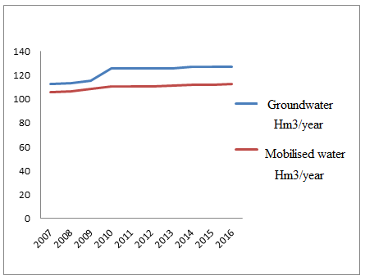
Figure 1. Evolution of groundwater mobilisation.
Mobilisation for domestic use
The exploitable local underground resources are estimated at 113.26 hm3/year, 153 boreholes have been drilled throughout the wilaya, 104 of which are exploitable, 45 boreholes are not exploitable and 04 are stopped. 94 of the 104 boreholes are intended for drinking water supply. The daily consumption is 80134 m3/d and the average supply calculated for the wilaya is 175l/d/inhabitant.
Table 2. Groundwater resources mobilised for water supply.
Wilaya | Groundwater (Hm3/year) | population ( (Inhabitant)) | Consumption (Vol.m3/d) | Supply (l/d/inhab)
Saida | 113,626 | 384200 | 80134 | 175
Source: Department of Water Resources wilaya SAIDA

Mobilisation for agricultural use
The production by type of use gave a volume of groundwater in the order of 71,544 hm3 the volume mobilised for agricultural use is 725,328 m3 /year from surface resources (03 wadis, namely oued Sefioun, Berbour and oued Saida). According to DRE data, water mobilisation for irrigation is carried out by 914 boreholes, 204 wells and 301 run-of-river abstraction points, the purified water being discharged directly into the wadis. The inventory of water points carried out in the wilaya by the DSA (2016), shows the results in Table 3.
Table 3. Status of resources mobilised for irrigation.
WILAYA | BOREHOLE |  | WELL |  | STEP |  | SOURCE |  | WADI
 | No. | Volume (m3/year) | No. | Volume  (m3/year) | No. | Volume  (m3/year) | No. | Volume  (m3/year) | No. | Volume  (m3/year)
SAIDA | 914 |  | 28.823.904 |  | 204 |  | 2.144.448 |  | 02
Source: Department of Water Resources wilaya SAIDA
Mobilisation for industrial use
The water mobilised for industry is provided by 7 boreholes and the water consumed by industry is 3.4 hm3 of which 1.85 hm3 is surface water and 1.55 hm3 comes from groundwater.
Infrastructure and mobilisation equipment
The mobilisation of water for the wilaya of Saïda is indeed confronted with the problem of the insufficient quantity of water to ensure the various needs of the wilaya, and to ensure a good quality of water, the water transferred from the Chott Chergui aquifer is mixed with that of Ain Zerga to improve its quality. Other mineral aquifers exist, in particular in Oued Fallette and Oum Doud where analyses revealed that their quality was the same as that of the mineral waters of Saïda.
Water supply
The wilaya of Saïda has an infrastructure of 11 main and secondary conveyances exceeding 1395452 ml of pipes with a conveyance capacity of around 83 51 m3/d. The Ain Skhouna pipeline, with a capacity of 43,200 m3/year, only transfers 50% of this volume to the city of Saïda. Thus, the conveyances currently transport a volume of 56,800 m3/d, i.e. 87% of the wilaya's drinking water needs for 2016.
Water storage
The wilaya's storage capacity was 80,435 m3 in 2009 and 96,960 m3 in 2016. This volume represents the capacity of 209 installations that guarantee a good supply of drinking water.
Supply of the urban grouping Saida, Ouled Khaled and Aïn El Hadjar
The city of Saida is located in a basin surrounded by hills on the sides of which the districts were built. This topographical characteristic has imposed a staggered distribution system to avoid excessive pressure in the lowest residential areas. The Saïda distribution network (supplying Saïda, Oueld Khaled and Aïn El Hadjar) is supplied with water from: the Chott Chergui aquifer from the C3 borehole (stopped due to technical problems) and the C5 borehole, which can provide a total flow of 500 l/s (currently operating at 250 l/s) via the Ain Skhouna transfer. From the karstic dolomite water table via 2 springs and 7 boreholes, i.e. a total estimated flow of 244 l/s.
Transfer from the Chott Chergui aquifer and water quality
The main objective of the water transfer from the Chott Chergui aquifer is to satisfy the various water needs and to protect the Saida mineral aquifer. The concerns were directed towards the quality of these waters, especially with the problem of salinity, analyses were made by the laboratory of hydrochemistry of the ANRH of Oran, led to the presence of a dry residue of1400 mg/l. The only solution to solve the problem of the salinity of the water taken is to mix 2/3 of the transferred water with 1/3 of the local groundwater (mineral water).

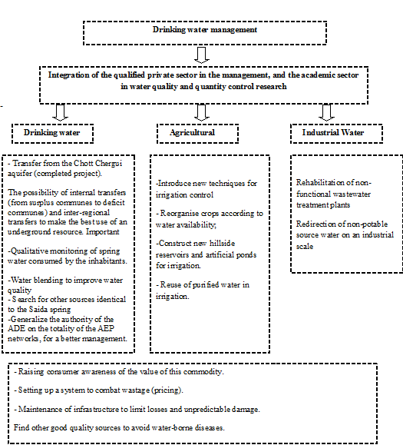
Figure 2. Water management approach in the wilaya of Saida.
CONCLUSION
The semi-arid climate and the quasi-permanent drought that has affected the western high plains region of Algeria for several years has presented the study area with major water resource problems. Faced with water resources that are becoming more and more limited in view of the increasing water needs due to economic development, the needs of the population, the needs of the agricultural and industrial areas in full development in a semi-arid region, it is necessary to set up a more efficient and reliable exploitation scheme for an optimal and rigorous long-term management of water resources. The mobilisation of water is confronted with a double problem, characterised by a limitation of local resources and an increasingly important recourse to the underground resources of Chotte Chergui to ensure the heavy deficit and to manage to satisfy the needs of the city of Saida (with a ratio of water availability of 200 m3/d/inhab). An increasing demand for industrial water, due to the development of the industrial fabric (Saida and Ain el Hedjar area). A high demand for agricultural water, due to the large areas to be irrigated and the growth of livestock. Good management must take into consideration the degradation of the quality of the water table due to overexploitation (salinity); the degradation of the quality of surface water due to poor sanitation management; and the extension of agricultural activities in the steppe.
REFERENCES
Bentabet, A., H. Azzaz, et al. (2019). "The impact of agricultural development on karstic groundwater of the Saïda Mountains, Algeria." Rudarsko-geološko-naftni zbornik (The Mining-Geological-Petroleum Engineering Bulletin) 34(4).
Drouiche, N., N. Ghaffour, et al. (2012). "Towards sustainable water management in Algeria." Desalination and Water Treatment 50(1-3): 272-284.
Ngene, B. U., C. O. Nwafor, et al. (2021). "Assessment of water resources development and exploitation in Nigeria: A review of integrated water resources management approach." Heliyon 7(1): e05955.
Nguyen, T. T., H. H. Ngo, et al. (2019). "Implementation of a specific urban water management-Sponge City." Science of The Total Environment 652: 147-162.
Olagunju, A., G. Thondhlana, et al. (2019). "Water governance research in Africa: progress, challenges and an agenda for research and action." Water International 44(4): 382-407.
Xie, M. (2006). Integrated water resources management (IWRM)–introduction to principles and practices. Africa Regional Workshop on IWRM, Nairobi, Oct.
Bentabet, A., H. Azzaz, et al. (2019). "The impact of agricultural development on karstic groundwater of the Saïda Mountains, Algeria." Rudarsko-geološko-naftni zbornik (The Mining-Geological-Petroleum Engineering Bulletin) 34(4).
Drouiche, N., N. Ghaffour, et al. (2012). "Towards sustainable water management in Algeria." Desalination and Water Treatment 50(1-3): 272-284.
Khiati, D., F. Z. Haouchine, et al. (2021). "Geochemical and geothermal characteristics of thermal springs of Saida region." Arabian Journal of Geosciences 14(14): 1-14.
Ngene, B. U., C. O. Nwafor, et al. (2021). "Assessment of water resources development and exploitation in Nigeria: A review of integrated water resources management approach." Heliyon 7(1): e05955.
Nguyen, T. T., H. H. Ngo, et al. (2019). "Implementation of a specific urban water management-Sponge City." Science of The Total Environment 652: 147-162.
Olagunju, A., G. Thondhlana, et al. (2019). "Water governance research in Africa: progress, challenges and an agenda for research and action." Water International 44(4): 382-407.
Xie, M. (2006). Integrated water resources management (IWRM)–introduction to principles and practices. Africa Regional Workshop on IWRM, Nairobi, Oct.

