**PREDICTABLE MOBILE NUMBER PORTABILITY FOR MOBILE NETWORK PROVIDERS**

**Nnochiri Ifeoma U**

Department of Computer Engineering, Michael Okpara University of Agriculture, Umudike

Email: nnochiri.ifeoma@mouau.edu.ng

**Iroegbu Chibuisi**

Department of Electrical/Electronic Engineering, Michael Okpara University of Agriculture, Umudike

Email: iroegbu.chibuisi@mouau.edu.ng

**ABSTRACT**

In this paper, predictable mobile number portability for mobile network providers is presented. The GSM networks studied were MTN and Glo.The actual measurements for this research were from various points of interest in Aba, (Abia State), Umuahia, (Abia State), and Mbaise, (Imo State). For each of the locations, measurements were taken at hourly intervals and the obtained data aggregated and averaged into the following Key Performance Indicators (KPIs) namely; Call Drop Rate (CDR), Call Setup Success Rate (CSSR), Agent Utilization Rate (AUR), Handover Success Rate (HSR), Awaiting Time (AWT) and Call Quality Factor (CQF) via the existing Base Station Controller (BSC) areas. Practically tariff plans, call quality factor, customer care services and network coverage parameters are more important for a customer to switch their operator. These four parameters were used for MNP prediction decision using fuzzy logic. The results showed that MTN NG ranked first with a prediction score of 78%, strongly followed by GLO NG with a prediction score of 77%. The research concludes that the prediction for mobile network providers could be of immense assistance should Nigerian Communication Commission decide to revisit the mobile number portability as earlier promised from the available literatures.

Keywords: Portability, Fuzzy logic, Call Quality Factor (CQF), Tariff plans, Customer care services, Network coverage

1.0 INTRODUCTION

Mobile Number Portability (MNP) can be defined as the capability of cellular phone users to toggle among network provider while maintaining their cellular phone numbers (Smura, 2019). The switching cost will be minimal since the subscribers have the right to retain their numbers. As a result, the subscribers are challenged with migrating expenses that came with informing public about changing their cellular phone numbers, redesigning their company headed letters, and being unreachable to important calls from the populace that don’t have their new cellular phone numbers, etc (Rajeev *et al.,* 2018).

Because of these factors, a lot of monitoring establishments have forced compulsory Mobile Number Portability (MNP) or at the verge of its beginning in order to bring subscribers migrating costs to its barest minimum, and its effort to make cellular phones industries highly accommodating and competitive (Buehler and Haucap, 2018).

Some of the few studies that have made attempt in the direction of this study were the works of Hashim (2014), Adeiza (2010); Jibrin and Ahmad (2014). These works had methodological problems: some concentrated in only one State or institution, while some dealt with isolated variable indicators. They also used small sample sizes selected from narrowly defined populations and, moreover, they failed to integrate the various independent variable sets. As a result, the findings and conclusions of the studies have limited relevance for broad generalizations. Therefore, this work was designed to overcome such deficiencies found in previous studies within the Nigerian context.

In this research, a predictable mobile number portability model for some selected mobile network providers was presented.

**2.0 REVIEW OF RELATED WORKS**

Lee *et al.* (2016) conducted a study in South Korea about factors which attracted customers in porting their numbers. It was discovered that there was willingness by customers to give a standard of 3.24% of their monthly cost for a mobile number portability choice. Willingness to pay (WTP) demonstrated a highly encouraging organization with proceeds, understanding of MNP, and aim to switch.

Contrary to these findings was a study by Haucap (2016), which found ambiguity about MNP in most European countries, the research results for this study indicated that MNP brought about 6% discount rates which was a benefit to consumers. The saturated market forced operators to bring prices of telecommunication down and quality of service was a determining factor in influencing customer choice more than prices. But the two researches fail to provide a platform for the deployment of their ideas to use.

A study conducted by Smura (2019) looked at Finland, Italy, Singapore and Germany on the implementation of MNP. His result shows that in Finland, MNP was only applicable to contract users who were 96% of the total users. Finland is among the countries which had a positive report on the effect of MNP to its consumers. This was attributed to enforcement powers which the regulator had. Bundled services, SIM - lock, lock in contracts and long contracts were banned. But the research failed to take into consideration the Key Performance Index of the networks in question.

Igbal (2017) conducted a study in South Asia about the effect of MNP and highlighted measures for the successes of MNP. First, he says that high porting numbers are indicative of the successes of MNP. He mentions several countries such as Hong Kong, South Korea and Australia introduced low prices. MNP has a harmful effect on interconnection rates. Complexities are associated with international interconnections rates which depend on a country's rates.

Interconnection is defined as ‘technical and business setting where network providers hook-up their infrastructure, services and network to allow users to access the networks and customer’s services of their respective network providers’. Interconnection must be regulated where competition in telecommunications services exists. However, the research fail to prove that competition is not an end but a means to an end (lower prices, high rates of innovation and investment) etc.

According to Nilsson, (2017), MNP involves a series of complex internal and external application integration. MNP is an IT infrastructure that comprises of a number of heterogeneous systems and customized applications, with a Web-based integration platform to support its important protocols which enables applications to communicate.

For MNP to be successful, it requires all the internal applications to be properly integrated with external applications identified as the central reference database of customers.

**3.0 MATERIALS AND METHODS**

The actual measurements for this research were from various points of interest in Aba, (Abia State), Umuahia, (Abia State), and Mbaise, (Imo State). For each of the locations, measurements were taken at hourly intervals and the obtained data were aggregated and averaged into the following Key Performance Indicators (KPIs) namely; Call Drop Rate (CDR), Call Setup Success Rate (CSSR), Agent Utilization Rate (AUR), Handover Success Rate (HSR), Awaiting Time (AWT) and Call Quality Factor (CQF) via the existing Base Station Controller (BSC) areas. The selected parameters were perceived to have direct impact to subscriber experiences on the network in the independent survey. The GSM networks studied were MTN and Glo.

**3.1 MNP DECISION ALGORITHM**

In actual, there are many parameters that should determine why customers would switch their operator but practically tariff plans, call quality factor, customer care services and network coverage parameters are more important for a customer to switch their operator. In this section, these four parameters would be used for MNP decision using fuzzy logic. On the basis of these four parameters, the decision whether MNP is to be done or not is considered. The tariff plan, call quality factor, customer care services and network coverage are input parameter and MNP is output parameter. Input parameter tariff plan gives the information of call rate per naira. In this research, tariff plan was taking from minimum of 5 available tariff plans to a maximum of 15 available tariff plans. The whole range was distributed in three levels: small, medium and large.

Fig. 1 shows the input membership function of the tariff plan. Cheap, affordable and expensive are used in defining the tariff plan.



Fig. 1: Input membership function1 (tariff plan)

From Fig. 1, it was seen that the degree of membership function for the tariff plan are equal, but the cost of the plan (kobo/sec) differs. When the cost of plan falls within 0 to 9.5 (kobo/sec), the tariff plan is said to be cheap. When it falls within 9.2 to 12.5 (kobo/sec), the tariff is said to be affordable. When it falls within11.9 to 15(kobo/sec), the tariff is said to be expensive.

Fig.2 shows the input membership function of the network coverage. Poor, average and strong are used defining the network coverage.



Fig.2: Input membership function 2 (network coverage)

From Fig.2, it was seen that the degree of membership function for the network coverage are equal to 1, but the network coverage in decibel (dB) varies. When the network falls within

-90 to -150 dB, the network coverage is said to be poor. When it falls within 0 to -110dB, the network coverage is said to be average. When it falls within -20 to 50dB, network coverage is said to be strong.

Fig. 3. shows the input membership function of the customer’s services. Unsatisfaction, Medium and Satisfaction are used defining the customer’s services.



Fig.3: Input membership function 3 (customer service)

From Fig. 3, it was seen that the degree of membership function for the customer service are equal to 1, but the service rendered varies in percentage. When the service ranged between

10 to 45%, the customer’s service is said to be unsatisfactory. When it varies between 33 to 82%, the customer’s service is said to be medium. When it varies between 69 to 100%, the customer’s service is said to be satisfactory.

If all the conditions as seen in Fig.1 to 3 are satisfied, then it gives the best MNP. If any one condition is low, or medium, then the result gives a moderate MNP. If any one condition is satisfied, but the remaining is low or medium, then it gives the result as a bad network.

Table 1 gives a rule block summary of the flow chart of figure defining the fuzzy logic decision rule. The MNP decision was taken based on the combination and analysis of the three input membership functions.

Table 1: Table showing 27 fuzzy inference rules for making MNP decision

|  |  |  |  |  |  |
| --- | --- | --- | --- | --- | --- |
|  |  |  | | RULE BLOCK |  |
|  |  |  |  |  |  |
|  |  | IF | |  | THEN |
|  |  |  |  |  |  |
| Network coverage |  | Tariff |  | Customer care | MNP |
|  |  |  |  |  |  |
| POOR |  | CHEAP |  | UNSATISFACTORY | LOW |
|  |  |  |  |  |  |
| POOR |  | CHEAP |  | MODERATE | LOW |
|  |  |  |  |  |  |
| POOR |  | CHEAP |  | SATISFIED | HIGH |
|  |  |  |  |  |  |
| POOR |  | AFFORDABLE |  | UNSATISFACTORY | LOW |
|  |  |  |  |  |  |
| POOR |  | AFFORDABLE |  | MODERATE | LOW |
|  |  |  |  |  |  |
| POOR |  | AFFORDABLE |  | SATISFIED | MEDIUM |
|  |  |  |  |  |  |
| POOR |  | EXPENSIVE |  | UNSATISFACTORY | VERY_ LOW |
|  |  |  |  |  |  |
| POOR |  | EXPENSIVE |  | MODERATE | VERY_ LOW |
|  |  |  |  |  |  |
| POOR |  | EXPENSIVE |  | SATISFIED |  |
|  |  |  |  |  | LOW |
| AVERAGE |  | CHEAP |  | UNSATISFACTORY | MEDIUM |
|  |  |  |  |  |  |
| AVERAGE |  | CHEAP |  | MODERATE | HIGH |
|  |  |  |  |  |  |
| AVERAGE |  | CHEAP |  | SATISFIED | HIGH |
|  |  |  |  |  |  |
| AVERAGE |  | AFFORDABLE |  | UNSATISFACTORY | MEDIUM |
|  |  |  |  |  |  |
| AVERAGE |  | AFFORDABLE |  | MODERATE | MEDIUM |
|  |  |  |  |  |  |
| AVERAGE |  | AFFORDABLE |  | SATISFIED | MEDIUM |
|  |  |  |  |  |  |
| AVERAGE |  | EXPENSIVE |  | UNSATISFACTORY | LOW |
|  |  |  |  |  |  |
| AVERAGE |  | EXPENSIVE |  | MODERATE | LOW |
|  |  |  |  |  |  |
| AVERAGE |  | EXPENSIVE |  | SATISFIED | MEDIUM |
|  |  |  |  |  |  |
| STRONG |  | CHEAP |  | UNSATISFACTORY | HIGH |
|  |  |  |  |  |  |
| STRONG |  | CHEAP |  | MODERATE | VERY_ HIGH |
|  |  |  |  |  |  |
| STRONG |  | CHEAP |  | SATISFIED | VERY_ HIGH |
|  |  |  |  |  |  |
| STRONG |  | AFFORDABLE |  | UNSATISFACTORY | MEDIUM |
|  |  |  |  |  |  |
| STRONG |  | AFFORDABLE |  | MODERATE | HIGH |
|  |  |  |  |  |  |
| STRONG |  | AFFORDABLE |  | SATISFIED | HIGH |
|  |  |  |  |  |  |
| STRONG |  | EXPENSIVE |  | UNSATISFACTORY | LOW |
|  |  |  |  |  |  |
| STRONG |  | EXPENSIVE |  | MODERATE | MEDIUM |
|  |  |  |  |  |  |
| STRONG |  | EXPENSIVE |  | SATISFIED | HIGH |
|  |  |  |  |  |  |

From Table1, a high MNP was obtained when there was either a moderate customer care, affordable tariff plan combined with strong network coverage. A low MNP was obtained when any two of the inputs were on the low side and the third input on the high side. A very low MNP was obtained when all three inputs were on the low side or any input on the medium and the other two input on the low side. Table 1 gives an understanding of the fuzzy rule using if and then comments.

Fig. 4 described the fuzzy inference system (FIS) showing the relationship among the three input membership functions cost tariff, network coverage, customer service and the output membership function. The FIS system was designed using the mamdani decision system with 27 inference rules.



Fig.4: Fuzzy inference system model showing all input and output functions with 27 rules

**3.2 Defuzzification**

The method of obtaining a numerical result based on a defined fuzzy set and on an output member function is called defuzziﬁcation. The output member function is shown in figure 5. The center of gravity technique was considered to defuzzify the fuzzy result. Equation (1) describes the defuzziﬁer technique.

$$fuzzycost=\frac{\left[\sum_{allrules}{R_{i}}× η\left(R_{i}\right)\right]}{\sum_{allrules}{η}\left(k_{i}\right)} (1)$$

Where Fuzzy Cost represents the degree of deciding factor $R_{i}$ denotes all fuzzy rules, $η\left(k_{i}\right)$ denotes all variables and $η\left(R_{i}\right)$ denotes its membership function. The output of the Fuzzy Cost function was changed to numerical result based on the above described defuzziﬁcation method.

Figure 5 shows the output of the Fuzzy Cost function. The MNP was divided into a set of $k_{i}$ variables. The output parameter MNP gives information of decision. In this, the MNP ranged from minimum 0% to maximum 100%. The whole range was distributed in five levels such as very low, low, medium, high, and very high.



Fig.5: Output membership function of the MNP fuzzy inference system

From Fig.5, it was seen that the degree of membership for the output membership function of the MNP fuzzy inference system were the same at 1, but the output MNP in percentage (%) varies.

When the MNP output ranges from 0 to 20%, the MNP output was said to be VERY LOW. When it falls between 18 to 42%, the MNP output was said to be LOW. When it ranged between 39 to 62%, the MNP output is said to be MEDIUM. When it varied between 58 to 90%, the MNP output was said to be HIGH, and when it ranged between 91 to 100%, the MNP output was said to be VERY HIGH.

**4.0 RESULTS AND DISCUSSION**

**4.1: PREDICTABLE MOBILE NUMBER PORTABILITY FOR STUDIED CASE KPI’s**

By considering the studied KPI’s, the fuzzy controller can be varied by modeling the average value of the KPI’s for the period under study. This is to determine a predictable mobile number portability for the period under study. Figure 6 shows the rule-viewer adjustable knob of the fuzzy inference system which can be used to obtain a predictable MNP for the studied network operators using the given KPI’s.

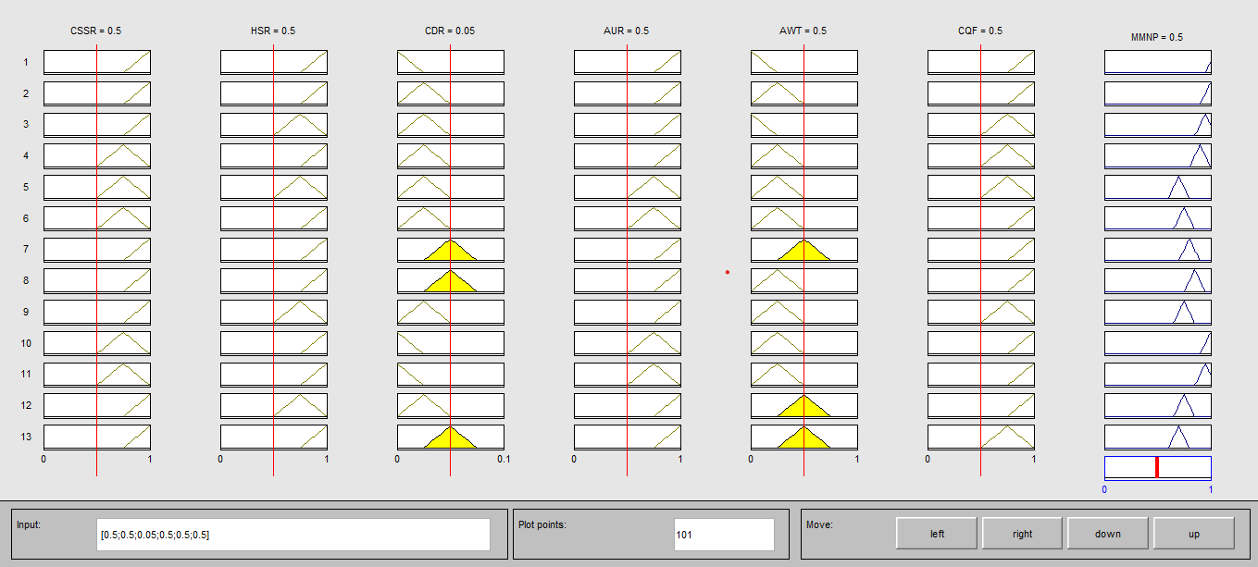

Figure 6: Rule viewer adjustable table for predicting MNP

Table 2 shows the predictable MNP for the months of June to November 2022

Table 2: The predictable MNP for the months of June to November 2022

|  |  |  |  |
| --- | --- | --- | --- |
| MNP (%) | | | |
| MONTHS | NCC | MTN NG | GLO NIG |
| JUNE | 0.8 | 0.75 | 0.75 |
| JULY | 0.8 | 0.811 | 0.821 |
| AUGUST | 0.8 | 0.721 | 0.791 |
| SEPTEMBER | 0.8 | 0.813 | 0.748 |
| OCTOBER | 0.8 | 0.721 | 0.70 |
| NOVEMBER | 0.8 | 0.861 | 0.80 |

Using the predictable MNP for the month of June 2022 in Table 2, a bar plot of Figure 7 was generated.

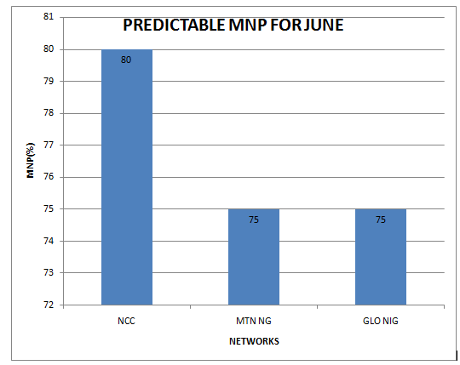

Figure 7: Plot of predictable MNP against network operators in the month of June, 2022.

From the plot of Figure 7, the standard predictable MNP for NCC was 80% (0.8). It can also be seen that for a user wishing to port to a better network, MTN NG and GLO NG were not able to meet the standard predictable MNP for NCC at 80%. Their MNP score was 75% each.

Using the predictable MNP for the month of July 2022 in Table 2, a bar plot of Figure 8 was generated.

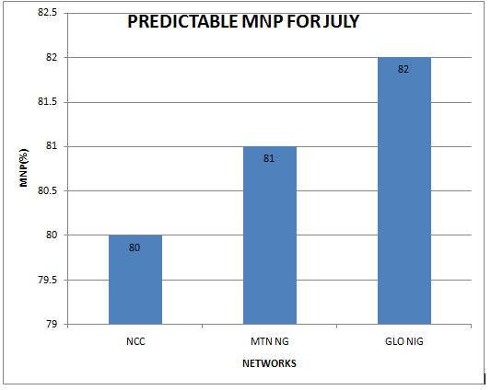

Figure 8: plot of predictable MNP against network operators in the month of July 2022

From the plot of Figure 8, the standard predictable MNP for NCC is 80%. It can also be seen that for a user wishing to port to a better network, GLO NG is the best networks operator to port into with MNP score of 82%. All networks predicted exceeded the NCC standard.

Using the predictable MNP for the month of August 2020 in Table 2, a bar plot of Figure 9 was generated.

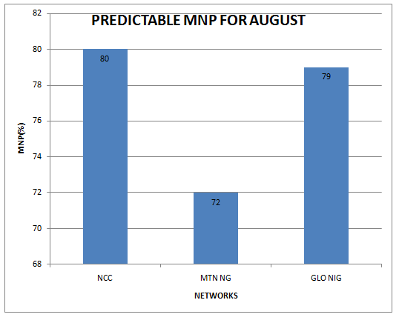

Figure 9: Plot of predictable MNP against network operators in the month of August 2022

From the plot of Figure 9, the standard predictable MNP for NCC was 80% (0.8). It can also be seen that for a user wishing to port to a better network, GLO NG is the best networks operator to port into with MNP score of 79 %.

Using the predictable MNP for the month of September 2022 in Table 2, a bar plot of Figure 10 was generated.

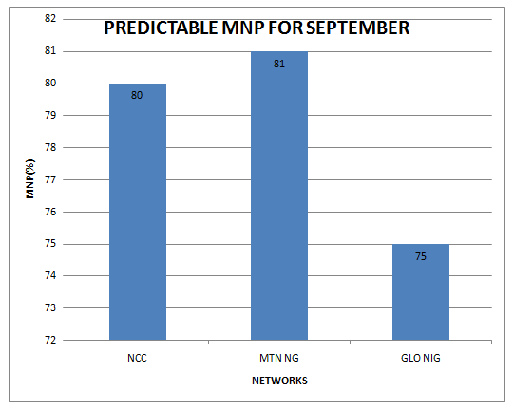

Figure 10: Plot of predictable MNP against network operators in the month of September 2022

From the plot of Figure 10, the standard predictable MNP for NCC is 80% (0.8). It can also be seen that for a user wishing to port to a better network, MTN NG is the best networks operator to port into with MNP score of 81%.

Using the predictable MNP for the month of October 2022 in Table 2, a bar plot of Figure 10 was generated.

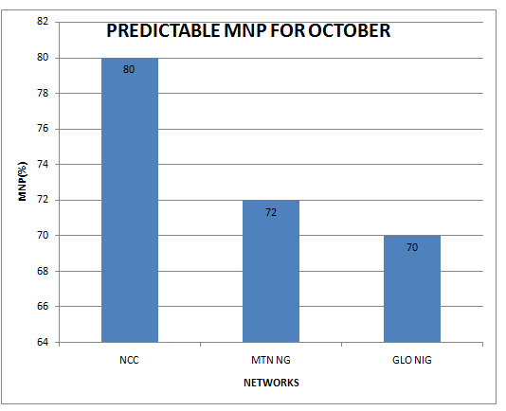

Figure 11: Plot of predictable MNP against network operators in the month of October 2022

From the plot of Figure 11, the standard predictable MNP for NCC was 80%. None of the network was able to meet the NCC predictable benchmark.

MTN NG had MNP score of 72%, strongly followed by the Glo with predictable MNP of 70%.

Using the predictable MNP for the month of November 2022 in Table 2, a bar plot of Figure 11 was generated.

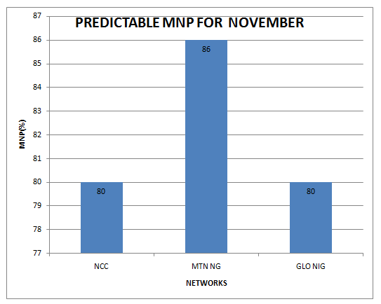

Figure 12: Plot of predictable MNP against network operators in the month of November 2022

From the plot of Figure 12, the standard predictable MNP for NCC was 80%. It can also be seen that for a user wishing to port to a better network, MTN NG is the best networks operator to port into with MNP score of 86%, 6% better than the NCC target, strongly followed by GLO NG, with an MNP score of 80%.

**4.2 AVERAGE PREDICTABLE MNP FOR THE STUDIED PERIOD**

To obtain the best predictable MNP of the considered network operators, the average of the MNP’s for the six months under study was obtained and the results is as shown in Table 3.

Table 3: Average predictable MNP score for the studied period

|  |  |  |  |
| --- | --- | --- | --- |
| **NETWORKS** | **NCC** | **MTN NIG** | **GLO** |
| **MNP** | **80** | **78** | **77** |

Using the Average predictable MNP score for the studied period in Table 3, a bar plot of Figure 13 was generated.

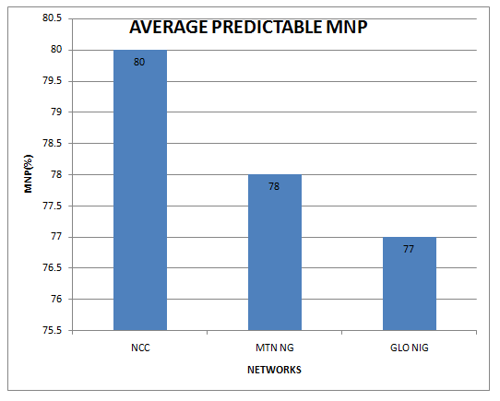

Figure 13: Plot showing average predictable MNP for the 6 months of study

From the plot of figure 13, it can be observed that taking an average of the MNP for the various networks under study, MTN NG ranked first with an average score of 78%, strongly followed by GLO NG with an MNP score of 77%.

**5.0 CONCLUSION**

In this research, predictable mobile number portability for mobile network provider’s decision using Fuzzy framework was developed. The customers’ parameters while focusing its evaluation based on a set of benchmarks which are considered as crucial for deployment while taking cognizance of user’s requirements of mobile devices was shown.

By considering the studied KPI’s, the fuzzy controller was varied by modeling the average value of the KPI’s for the period studied.

The prediction for mobile network providers could be of immense assistance should Nigerian Communication Commission decide to revisit the mobile number portability as earlier promised from the available literatures.

**REFERENCES**

Adeiza A. (2010). Effects of Brand Association on Consumer Patronage of GSM Service Providers in Kano Metropolis. *M.Sc* *Dissertation*, Business Department, Bayero University Kano, 20.

Buehler, S., and Haucap, J. (2018). Mobile Number Portability. *Journal of Industry,**Competition and Trade*, 4(3): 223-238.

Hashim Y. M. (2014). Determinant of Customer Loyalty Among Subscribers of Global System for Mobile (GSM) Communication in North-Western Nigeria. The 2014 *WEI International Academic Conference Proceeding* New Orleans USA. 8:6-9.

Haucap, J. (2016). Endogenous Switching Costs and Exclusive Systems Applications. *Review of Network Economics*, 1, 29-35.

Igbal, T. (2017). Mobile Number Portability: The Case for and Against. *LIRNE asia*. Retrieved August 13, 2017 from: <http://lirneasia.net/20017/10/mobilenumber-portability-the-case-for-and-against/>

Jibrin. N. S and Ahmad, A. (2014). Appraisal of Customer Satisfaction and GSM Services in Dutsinma, Katsina State. *European Journal of Business and Management*, 6(35): 19-24

Lee, J., Kim, Y., and Park, Y. (2016). Estimating The Extent of Potential Competition in the Korean Mobile Telecommunications Market: Switching Costs and Number Portability’’, *International Journal of Industrial Organization*. Vol 6, No. 7. Pp 90-99.

Nilsson, G. (2017). Number Portability: A Networking Perspective. *Telecommunications Magazine,* Retrieved July 24, 2017, from <http://www.telecomsmag>. com/marketing/articles/jul97/nilsson.html

Rajeev, R. K., Amrita, S., and Damodaram, A. (2018). Phone Number Portability in GSM Networks”, *CSI* Vol. 32, Issue-7, Oct.2018. Pp 34-39.

Smura, T. (2019). Mobile Number Portability. *Case Finland, Mimeo, Networking Laboratory, Helsinki University of Technology. 78.*

**Appendix 1: The KPI raw data**

