Adsorption of Congo Red Dye from Aqueous Solution by Carbonised Cowpea (Vigna Unguiculata) Husk: Kinetics, Equilibrium and Thermodynamics Studies

Abdullahi Muhammad Ayuba and Bridget Idoko*
Department of Pure and Industrial Chemistry, Bayero University, Kano, Nigeria.
*Corresponding author email: bridgetidoko0803@gmail.com

Abstract
Kinetics, equilibrium isotherms and thermodynamics of Congo red adsorption onto adsorbent derived from Cowpea husk (Vigna unguiculata) were investigated in a series of batch experiments. The carbonized cowpea husk (CCPH) without any modification, was characterized by Fourier transform infrared spectroscopy (FTIR) and Scanning Electron Microscopy (SEM) methods. Optimum removal efficiency of Congo red by the adsorbent occurred at pH of 6.0 at lower adsorbent dosage, attaining a peak value of 79.55%(19.88mg/g) after 1 hour of agitating time. Findings also revealed that, among the kinetic and isotherm models tested, the experimental data fitted best to pseudo-second order model (R²= 0.997) and Freundlich adsorption isotherm (R²= 0.938). The adsorption process through the determined thermodynamic parameters was found to be feasible and spontaneous with a proposed physical adsorption mechanism. The study demonstrates that carbonized Cowpea husk can serve as an alternative low-cost adsorbent for the removal of Congo red from industrial wastewater.
Keywords: Adsorption, Congo red, Isotherm, Kinetics, Vigna unguiculata
1. Introduction
Dyes have long been used in dyeing, paper and pulp, textiles, plastics, leather, cosmetics and food industries. Color stuff discharged from these industries poses certain hazards and environmental problems. These colored compounds are not only aesthetically displeasing but also inhibiting sunlight penetration into the stream and affecting aquatic ecosystem [1]. Dyes usually have complex aromatic molecular structures which make them more stable and difficult to biodegrade [2]. Congo red is a water-soluble dye and can be used as a pH indicator due to its color change from blue to red at pH 3.0 – 5.2. Besides serving as an indicator, Congo red has also been shown to have certain histological uses, especially as a cytoplasm and erythrocyte stain. It is currently being used to stain a variety of other biological tissue constituents, including cellulose, amyloid and elastic fibers. As a result of enormous utilization of Congo red, substantial amount of this dye is released into the environment during production, usage and disposal. [3-4]
The presence of Congo red dye in wastewater is not desirable because of its toxic nature to the life and environment into which they are discharged. Therefore, the removal of such compounds from wastewater is a vital task [5]. Adsorption process using carbon from agricultural waste is widely used to remove pollutants from wastewaters [6]. In the last years, special emphasis on the preparation of carbons from several agricultural by-products has been given much attention, due to the growing interest in low cost carbons from renewable, copious, especially for application concerning treatment of wastewater [7-8]. In this study however, the ability of cowpea husk carbon to remove Congo red by adsorption is been studied.
Fig 1: Structure of Congo Red dye
2. Materials and Method
2.1 Materials
Congo red dyes were obtained from E. Merck (Mumbai, India). Cowpea husk was obtained from Dawanau market, Kano state, Nigeria. All other reagents used were of analytical grade and were used as obtained. Distilled water was used throughout for the preparation of stock and working solutions. The stock solution of CR was made by dissolving 1g CR in 1-liter distilled water to make a 1000 mg/L in a 1000ml volumetric flask. Solutions were adjusted to desired pH using 0.1M NaOH or 0 .1M HCl.

2.2 Methods
2.2.1 Adsorbent preparation
The cowpea husk (CPH) was obtained by removing the bean seeds. CPH was first washed with water to remove dirt from its surface and subsequently dried at 105º C for 24 hrs. in an oven to remove the moisture content [9].

2.2.2 Carbonization of cowpea husk
For the preparation of carbon, methods reported in literature were largely used without modification [10-11]. Cowpea husk (20g) samples were carbonized at 400ºC for 1hr in a muffle furnace in order to produce charcoal. The sample was crushed with blender and sieved to pass through 850 μm to obtain the charcoal of cowpea husk

2.2.3 Adsorbate solution
The adsorbate, Congo red (CR) dye (chemical formula = C₃₂H₂₂N₆Na₂O₆S₂, Molecular weight = 696.665g/mol, Appearance = Brown Powder Purity = ≥95%)was obtained from Sigma Aldrich. The structure of Congo Red is illustrated in Fig.1. Stock solution was prepared by dissolving accurately weighed quantity of dye to make a concentration of 1000 mg. L⁻¹ in distilled water. The experimental solutions of desired concentration were prepared accordingly by diluting the stock solution with distilled water. The concentration of CR dye was measured at λ_{max} = 548.5 nm using UV–Visible spectrophotometer (Model Hitachi 2800).

2.2.4 Characterization of the Adsorbents
The surface morphological properties of adsorbents samples were investigated using Scanning Electron Microscope (Phenom World Eindhoven). Scanned micrographs of adsorbents before and after adsorption were taken at an accelerating voltage of 15.00 kV and x500 magnification. FTIR analysis of adsorbents before and after adsorption was carried out using Cary 630 Fourier Transform Infrared Spectrophotometer Agilent Technology. The analysis was done by scanning the sample through a wave number range of 650 – 4000 cm⁻¹; 32 scans at 8cm⁻¹resolution.

2.2.5 Batch adsorption experiment with optimization
A 0.1 g portion of the carbonized cowpea husk sample was weighed into different 100 ml conical flasks and 10 ml of working standard solution (50, 100, 150, 200, 300 and 500) ppm of the Congo red dye was added separately to the carbonized cowpea husk sample in the flask. Each solution was agitated on a flat orbital mechanical shaker for one hour and then filtered. The filtrate was then analyzed using ultraviolet-visible spectrophotometer at 517 nm to determine the quantity ofdye remaining in the solution. The data generated from the experiment were then used to study the various isotherm models. The equilibrium concentration (concentration with the highest adsorption capacity), was selected for use in the subsequent experiments [12-13].
Further experiment was carried out using the equilibrium concentration at varying solution temperature (varied from 303 to 333K). The amount of the dye adsorbed by the adsorbents at equilibrium was determined using the mass balance equations (1 and 2). The data generated from this experiment were then used to study the various thermodynamic parameters.
$Q_{e}$ = $\frac{(Co-Ce)}{m}×V$ (1)
R_{em} (%) = $\frac{(Co-Ce)}{Co}×100$ (2)

Where Q_{e} is the adsorption capacity (mg/g), C_{o} and C_{e} are the initial and final equilibrium concentration (mg/l) of Congo red in solution, Vis the volume of Congo red in solution (L), and m is the mass (g) of the adsorbent.

3. Results and Discussion
3.1 Adsorbent characterization
Fourier transform infrared spectroscopy of the adsorbent before and after adsorption of CR onto CCPH was done by using an FTIR spectrophotometer in the range from 600 to 4000cm−1, in order to determine the functional groups present in the adsorbent surface.
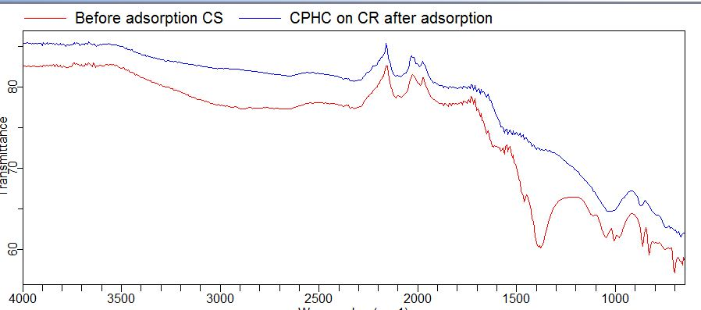
Figure 2: FTIR spectral of CCPH before and after adsorption on CR
The FTIR spectra in Fig 2 shows spectra of C-CPH before and after adsorption of CR. Peaks at 1562cm⁻¹ and 1402cm⁻¹ are associated with stretching vibration of aromatic ring and C-H in alkanes, while the peak 870cm⁻¹ is due to stretched vibration of C-O in aromatic, esters and ethers.
After adsorption, there was a shift and broadening of adsorption peaks. The shift of the C-H group peak from 866cm⁻¹ for Congo red also shows that this group participated in the adsorption of dyes. The presence of these functional groups and their enhancement in adsorption abilities of carbonized adsorbent agrees with the findings of other authors [14]

Table 1 Different functional group recognized before and after adsorption of CR onto CCPH
Functional  Group | Wavelength class range (cm⁻¹) | Before adsorption | After adsorption | Difference
C-H Alkanes | 2850- 2960  1350- 1470 | 2948  1402 | - | -
C≡C Alkynes | 2100- 2260 | 2113 | 2113 | 0
C=CAromatic | 1500-1600 | 1562 | 1562 | 0
C-O stretch | 1080- 1300 | 1048 | 1011 | -22
C-H aromatic | 675- 870 | 866 | 873 | -7

The micrograph obtained through Scanning Electron Microscopy (SEM) for the surfaces of C-CPH before adsorption (Figure 3a) shows the morphology of the surface to be rough, heterogeneous and irregular with crevices which enhances adsorption [15]. Figure 3b shows formation of clusters on the adsorbent surfaces after adsorption of CRindicating that the dye molecules had covered the rough surface of adsorbents, decreasing its roughness after adsorption process.
.
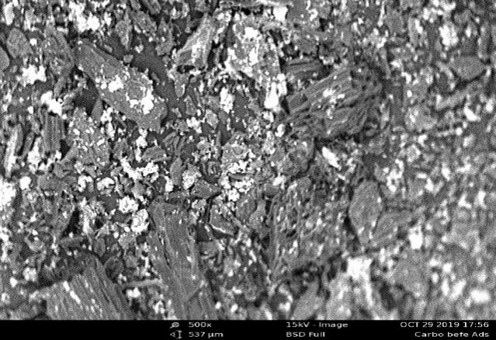 | 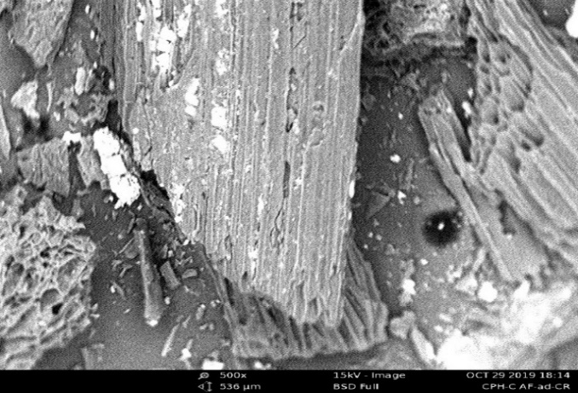
(a) | (b)
Figure 3. SEM Micrograph of CCPH (a) before and (b)after adsorption of CR

3.2 Batch Adsorption
Fig 4a shows the effect of contact time on the adsorption ofCongo red (CR) at an initialconcentration of 50mg/l, the batch experiments were carried out in a series of 250ml conical flasks with a constant C-CPH dose of 0.1g/L in all the samples. The absorption capacity qe was evaluated for all the samples and a graph was plotted between qe versus time as shown in Fig.4(a) below. The higher sorption rate at the initial period (first 60 minutes) CR may be due to availability of large number of vacant sites on the adsorbent at the initial stage, as a result there was an increased in concentration gradients between adsorbate in solution and adsorbate on adsorbent surface, thus tends to increase in dye sorption at the initial stages [16].
The effect of initial concentration of CR was investigated by varying the concentration from 50 to 500mg/L, at natural pH of dye solution, with agitation time and speed of 1hr and 130rpm respectively as shown in figure 4b. It is evident from the plot that the amounts of CR adsorbed by CCPH increases with increasing concentration. At low concentration, the available driving force for transfer of CR molecule onto the adsorbent particle is low. While at high concentration, there is a corresponding increase in the driving force, thereby, enhancing the interaction between the CR molecules in the aqueous phase and the active sites of the adsorbent. As a result of this, there was an increase in the dye uptake as adsorption capacity increases from 21.82mg/g to 166.64mg/g [17].

Fig4: Effect of (a) Contact time (b) initial concentration on the adsorption of CR onto the CCPH

The effect of adsorbent dosage of C-CPH was studied by varying amounts of adsorbent dosage from 0.1g to 0.8g for CR while other parameters were kept constant. Figure 5a below revealed that the amount CR adsorbed decreased with an increase in adsorbent dosage dueto possible overlapping of adsorption sites as adsorbent dosage increases which will equally reduce the effective adsorption sites. [13]. Maximum removal was attained when 0.1g of the adsorbent was used. The decrease in adsorption per unit mass with increasing dosage of adsorbent is attributed to possible overlapping of adsorption sites as adsorbent dosage increases which will equally reduce the effective adsorption sites. It was observed that the adsorption capacity decreased from 18.47mg/g to 3.21mg/g for CR. Similar trends were reported by other authors[18-19].
The effect of pH on the adsorption of Congo red (CR) was studied by varying the pH using a pH meter and adjusting with a 0.1M NaOH and 0.1M HCl. The uptake and percentage removal of CR from the aqueous solution are strongly affected by the pH of the solution as illustrated in Fig 5b. The uptake of CR decreases from 24.75mg/g to 9.36mg/g for CR when the pH increases from pH 2 to pH 9. The maximum adsorption of CR molecules was achieved at 2. The adsorption capacity decreased with an increase in pH up to 2. This is due to a decrease in competition between hydrogen ions for the surface sites and also due to a decrease in positive surface charge. At low pH however, the higher concentration and mobility of H⁺ ions favor its adsorption as seen. Furthermore, at lower pH, the surface of the adsorbent is surrounded by hydrogen ions (H⁺) thereby blocking CR molecules from binding sites on. A similar trend was observed in the studies of sorption of Pb(II) and Cu(II) onto magnetite eggshells–Fe₃O₄ powder [20].

Fig5: Effect of (a) Adsorbent dose (b) pH of the CR adsorption onto CCPH

3.3 Adsorption Kinetics
(a) The pseudo first-order equation
The pseudo first-order equation is generally expressed as follows:
$\frac{∂q_{t}}{∂t} =k_{1}(q_{e}-q_{t})$ (3) [21]
Where q_{e}and q_{t} are the adsorption capacity at equilibrium and at time t, respectively (mg·g⁻¹), k₁is the rate constant of pseudo first-order adsorption(l·min⁻¹). After integration and applying boundary conditions t = 0 to t = t and q_{t}= 0 to q_{t}= q_{t}, the integrated form becomes:
log($q_{e}-q_{t})$= log ($q_{e}$ )-$\frac{k_{1}}{2.303}$t (4)
The values of log (q_{e} – q_{t}) were linearly correlated with t. The plot of log (q_{e} – q_{t}) vs. t gave a linear relationship from which k₁ and q_{e}were determined from the slope and intercept of the plot respectively.
(b) The pseudo second-order equation
The pseudo second-order adsorption kinetic rate equation is expressed as
$\frac{∂q_{t}}{∂t}$= $k_{2}\left(q_{e}- q_{t}\right)$² (5)
k₂is the rate constant of pseudo second-order adsorption (g·mg⁻¹·min⁻¹). For the boundary conditions t = 0 to t = t and q_{t}= 0 to q_{t}= q_{t}, the Integrated form of Eq. (5) becomes:
$\frac{1}{(q_{e}- q_{t})}$= $\frac{1}{q_{e}}$ + k_{t} (6)
This is the integrated rate law for a pseudo second-order reaction
The equation can be rearranged to obtain Eq. (7), which has a linear Form:
$\frac{t}{q_{t}}$ = $\frac{1}{K_{2 q_{e}^{2}}}$ + ${\frac{1}{q}}_{e}\left(t\right) (7)$
If the initial adsorption rate, h (mg·g⁻¹·min⁻¹) is;
h = $k_{2}q_{e}^{2}$ (8)
Then eqn (7) becomes
( $\frac{1}{q_{t}}$) =$\frac{1}{h}$ +$\frac{1}{q_{e}}$(t) (9)
The plot of (t/q_{t}) and t gave a linear relationship from which q_{e}and k₁were determined from the slope and intercept of the plot respectively.
(c) Elovich Equation
The Elovich kinetic model is described by the following relation
q_{t}= 1/β ln (αβ) + (1/β) ln t (10) [22]
This model gives useful information on the extent of both surface activity and activation energy for adsorption process. The parameters (α) and (β) was calculated from the slope and intercept of the linear plot of qt versus ln(t).

(d) Intraparticle Diffusion Equation
The slowest step in an adsorption process is usually taken as the rate determining step. This step is often attributed to pore and intra particle diffusion. Since pseudo first and pseudo second order models cannot provide information on effect of intra particle diffusion in adsorption, intra particle diffusion model can be used. Possibility of involvement of intra particle diffusion model as the sole mechanism was investigated according to Weber–Moris equation [23]:
q_{e}= C + k_{int}t_{1/2} (11)
Where the constant k_{int}(mg/g min^{0.5}) is the intra particle diffusion rate and C is the boundary layer thickness. If the rate-limiting step is only due to the intra particle diffusion, then q_{t} versus t_{1/2} will be linear and the plot passes through the origin.

Table 2 Kinetic models for the adsorption of CR onto C-CPH
Kinetic models |  | Parameters
Pseudo-first order |  | q_{eExp}(mg/g) | q_{eCal}(mg/g) | K₁(min^{-s}) | R²
 |  | 19.888 | 3.310 | 0.013 | 0.659
Pseudo-second order |  | q_{eExp}(mg/g) | q_{eCal}(mg/g) | K₂(min^{-s}) | R²
 |  | 19.888 | 19.305 | 0.026 | 0.997
Elovich |  |  | Β | Α | R²
 |  |  | 0.787 | 1.138x10⁻¹⁹ | 0.676
Intra particle diffusion |  |  | K₃ | C | R²
 |  |  | 0.384 | 15.337 | 0.629

Table 2 above shows the result of the kinetic studies of the adsorption of CR unto CCPH. The kinetics studies of any adsorption system describe the rate of adsorbate uptake on adsorbent, and it controls the equilibrium time. The kinetic parameters are helpful to give information about uptake rate, which gives important information for designing and modeling the adsorption processes. As observed in figure 6b, the pseudo-second-order kinetic model fits the experimental data quite well; the correlation coefficients values, R² is almost unity, and the experimental and theoretical uptake are in good agreement. This indicates the applicability of the second-order kinetic model to describe the adsorption process of CR onto the adsorbent [24].

Figure 6: (a) pseudo-first order (b) pseudo-second order (c) Elovich linear (d) Intra particle diffusion plot for adsorption of CR onto CCPH

3.4 Adsorption Isotherm
In the present study, three models were tested which include; Freundlich, Langmuir and Temkin isotherm models.
(a) The Freundlich isotherm model assumes multilayer adsorption, with non-uniform distribution of adsorption heat and affinities over the heterogeneous surface.
log$Q_{e}=logkf+\frac{1}{n}logC_{e}$ (12)
Where q_{e} is the quantity adsorbed in mg/g, C_{e} is the equilibrium concentration of the adsorbate in mg/L, K_{f} is the Freundlich constant related to maximum adsorption capacity, n is the Freundlich constant related to surface heterogeneity (dimensionless).

(b) Langmuir isotherm model assumes monolayer adsorption onto a surface containing a finite number of identical sites. The model assumes uniform energies of adsorption onto the surface and no transmigration of adsorbate in the plane of the surface.
$\frac{1}{q_{e}}=\frac{1}{Q_{o}}+\frac{1}{Q_{oKLC_{e}}}$ (13)
Where q_{e} is the concentration of dye retained by adsorbent in mg/g or mol/g, C_{e} is the concentration of dye in solution, mg/L or mol/L,K is a curve fitting parameter for equilibrium model and q_{o} is the maximum adsorption capacity.

(c) Temkin isotherm model assumes that heat of adsorption (function of temperature) of all molecules in the layer would decrease linearly rather than logarithmic with coverage [25].
q_{e} = RTblnK_{T} + RTblnC (14)
Where K_{T} is the equilibrium binding constant (L/mol) corresponding to the maximum binding energy,b is related to the adsorption heat,R is the universal gas constant (8.314 J /K/mol) and T is the temperature (K).

Table 3 Isotherm Constant for the adsorption of CR onto carbonised Cowpea husk
Langmuir |  |  | Freundlich |  |  |  | Temkin
Qmax | K_{L}(L/mg) | R² | 1/n | N | k_{f} | R² | A | B | R²
285.71 | 0.017 | 0.894 | 1.655 | 0.604 | 10.21 | 0.938 | 3.164 | 26.432 | 0.857

Table 3 shows Langmuir, Freundlich and Temkin Isotherm constants for the adsorption of CR onto CCPH. The values of R² suggest that the Freundlich isotherm provides the best conformity with experimental data for CR. However, it can be concluded that the process be assumed to be a physical adsorption.

3.5 Thermodynamics
In an effort to examine in greater details the effect of temperature on the sorption of Congo red by carbonised cowpea husk, thermodynamic parameters such as Gibb’s free energy change (ΔG), enthalpy change (ΔH) and entropy change (ΔS) were estimated using equations 15, 16 and 17
Kc = Qe/Ce (15)
ΔG = −RTlnK_{c} (16)
lnk_{c}= -∆G/RT = −(∆H/RT) + (∆S/R) (17)
Table 4 Thermodynamics Parameter Of CR Adsorption On carbonised Cowpea Husk
T(K) | Qe(mg/g) | ΔG(kJ/mol) | ΔH (kJ/mol) | ΔS(J/mol.K)
303 | 16.288 | -1576.24 | 20.91 | -0.0103
313 | 16.762 | -1848.68
323 | 18.258 | -2675.24
333 | 20.541 | -4229.23

Generally, the negative ΔG values show spontaneous feasible adsorption process and the decrease in its value by rising temperature shows the physical nature of the adsorption process. The positive value of the enthalpy change (ΔH) signifies an endothermic process (heat gain) which is evident in the increased adsorption capacity of the dye at higher temperatures. Similar result was reported by another author [26]. The magnitude of ΔH describes the type of adsorption, where the heat of physical adsorption falls into the range of 2.1–20.9kJ/mol an indication of physical adsorption. All results obtained in this study is the normal consequence of the physical adsorption, which takes place through electrostatic interactions. The negative values of ΔS, suggests a decrease in randomness at the adsorbent-solution interface during the adsorption of dyes ions on the adsorbent surface. The negative entropy of the adsorption and immobilization of the dye ions on the adsorbent surface may be attributed to the decrease in the degree of freedom of the dye ions [27-28].

CONCLUSION
From the adsorption efficiency, kinetic and thermodynamicstudies of the adsorption of Congo red ontocarbonized cowpea husk studied, the resultsobtained from the analysis show that cowpea husk is a potential goodlow-cost adsorbent for the removal of thishazardous dye from wastewater. The process of the adsorption is feasible, spontaneous and obeyed the mechanism of physical adsorption processes.

ACKNOWLEDGEMENT
The authors wish to thank all the technical staff of Chemistry Laboratory, (Bayero University Kano) for their willingness and readiness to assist at all times in the research laboratory.
REFERENCES
- Akinola, L.K., Ibrahim, A., and Chadi, A.S. Kinetic and Equilibrium Studies of Congo Red Adsorption on Adsorbent from Bambara Groundnut Hulls Al-Hikmah, Journal of Pure and Applied Sciences, 2016, 2(2), 79-88.
- Forgacs E., T. Cserhati, G. Oros, Environ. Int., 30 (2004)., 953–971
- Monash P, Niwas R,Pugazhenthi G, Effect of TiO₂ addition on the fabrication of ceramic membrane supports Clean Techn. Environ. Policy, 13 (2011).141-151
4. Han, R.P., Ding, D., Xu, Y.F., Zou, W.H., Wang, Y.F., Li Y.F. Use of rice husk for the adsorption of congo red from aqueous solution in column mode. Bioresource Technology 99: (2008) 2938-2946
5. Ash, B., Satapathy, D., Mukherjee, P.S., Nanda, B., Gumaste, J.L., Mishra, B.K. Characterization and application of activated carbon prepared from coir pith, J.Sci.Ind.Res. 65 (2006). 1008-1012.
6. Sugumaran, P., Priya, V. S., Ravichandran, P., and Seshadri, S. Production and Characterization of Activated Carbon from Banana Empty Fruit Bunch and Delonix regia Fruit Pod Journal of Sustainable Energy & Environment 3 (2012). 125-132
7. Vibhawari, P, N.D. Single and competitive sorption of heavy metal ions of (Cd2+ and Cu2+) on a clayey soil. E-J Chem, 7 (2012). SI: S27–S34..
8. Adekola F.A., and Abdus-Salam N., Abdul-Rauf L. B. Removal of arsenic from aqueous solution by synthetic hematite. J Chem Soc Niger, 36(2) (2011) :52–58
9. Li, J.M., Meng, X.G., Hu, C.W., and Du, J. Adsorption of phenol, p-chlorophenol and p-nitrophenol onto functional chitosan. Bioresource Technology, 100 (2009).: 1168–1179.
10. Kumar, Y.P., King, P., Prasad, V.S.R.K. Removal of copper from aqueous solution using Ulva fasciata sp. Marine green algae. J Hazard Mater; 137(2007).:367–73.

11. Altenora S., Carenea B., Emmanuel E., Lambert J., Ehrhardt J., Gasparda S., Adsorption studies of methylene blue and phenol onto vetiver roots activated carbon prepared by chemical activation, Journal of Hazardous Materials, 165 (2009): pp.1029–1039.
12. Dalal, Z., Husein, E. A., and Maram, B. Adsorption of Cadmium (II) onto Watermelon Rind Under Microwave Radiation and Application into Surface Water from Jeddah, Saudi Arabia. Arab J Sci Eng. 14 (2016) 237-241
13. Ahalya, N., T.V. Ramachandra, T. V., and Kanamadi, R. D. “Removal of hexavelent chromium using coffee husk”, Bioresources technology, 2 (2006), 85-105.
14. Yusuf, K., Ozkan, A., Handan, U. Biosorption of Lead (II) and Zn(II) from aqueous solution by Nordmann fir Abies nordmanniana (Spach. Subsp. Nordmanniana) cones. Acta Chim Slov 56 (2009).:451–456.
15. Sebata, E., Moyo, M., Guyo, U., Ngano, N.P., Nyamunda, B.C., Chigondo, F., Chitsa, V., Shumba, M. Department of Chemical Technology Midlands State University Gweru, Zimbabwe. International Journal of Engineering Research and Technology, 2(5) (2013). 2278-0181.
16. Abdus-Salam, N., and Adekola, S. K. Adsorption studies of zinc (II) on magnetite, baobab (Adansonia digitata) and magnetite–baobab composite Applied Water Science, 28 (2018). -222. https://doi.org/10.1007/s13201-018-0867-7.
17. Saed K, Johari M., Noor M. M and Yusuf B. Sugarcane bagasse as an adsorbent for dye removal Journal of Industrial Pollutio Desalination n Control, Vol. 21, 2005. pp. 3,
18. Yeddou, N., Bensmaili, A. Equilibrium and kinetic modelling of iron adsorption in eggshells in a batch system: effect of temperature. 206(1–3) (2007).:127–134.
19. Lagergern, S. About the theory of so-called adsorption of soluble substances. K. Sven. Vetenskapsakad. Handl. 24 (1898)., 1–39.
20. Guo, S., Liang, X., Feng, N., Tian Q. Isotherms, kinetics and thermodynamic studies of adsorption of Cu²⁺from aqueous solutions by Mg^{2+/}K⁺ type orange peel adsorbents. J. Hazard. Material. 174 (2010), 756–762.
21. Freundlich, Colloid and Capillary Chemistry, 5th Edition, E.P .Dutton and Co. New York, pp. 132-137, 1928.
22. Limousin, G., Gaudet, J. P., Charlet, L., Szenknect, S., Barthes, V., & Krimissa, M. Sorption isotherms: a review on physical bases, modeling and measurement. Applied Geochemistry, 22(2) (2007)., 249-275.
23. Ogugbue, C. J., & Sawidis, T. Bioremediation and detoxification of synthetic wastewater containing triarylmethane dyes by Aeromonas hydrophila isolated from industrial effluent. Biotechnology research international, 16 (2011)167-169
24. Jain, A. K., Gupta, V. K., Jain, S. & Suhas. (2004). Removal of chlorophenols using industrial wastes. Environmental Science Technology, 38(4) (2011): 1195–1200
25. Mittal, A., Mittal, J., Malviya, A., Kaur, D., & Gupta, V. K. Adsorption of hazardous dye crystal violet from wastewater by waste materials. Journal of Colloid and Interface Science, 343(2) (2010), 463-473.
26. McKay G., Use of adsorbents for the removal of pollutants from waste waters. CRC, USA 208. (1995)
27. Kannan, N., Sundaram M.MKinetics and Mechanism of removal of methylene Blue by adsorption of various carbon- A Comparative study. Dyes pigments 51: (2001). 25-40
28 Malik R, Ramteke DS, Wate SR. Adsorption of malachite green on groundnut shell waste based powdered activated carbon. Waste Mgt.;27(9): 2007 129–1138.

