AWARENESS AND HARMFUL EFFECTS OF STEROID USE AMONG MESOMORPHIC ATHLETES IN CALABAR METROPOLIS

AUTHORS
1. ODEY, PAUL ANYIOM¹
Anyiomodey100@gmail.com
2. AJANG, CLETUS UGBAKA¹
ajangcletuz@gmail.com
3. OGAN, CHRISTOPHER AKANAKU²
c.ogan@ymail.com
5. IKPA, JAMES ONAH²
jamesonahikpa@gmail.com
AFFILIATED INSTITUTIONS
- DEPARTMENT OF ANATOMICAL SCIENCES, COLLEGE OF MEDICINE, UNIVERSITY OF CALABAR, CALABAR-NIGERIA
- DEPARTMENT OF ANATOMY AND FORENSIC ANTHROPOLOGY, FACULTY OF BASIC MEDICAL SCIENCES CROSS RIVER UNIVERSITY OF TECHNOLOGY (CRUTECH), CALABAR-NIGERIA

Correspondence: Ikpa, James Onah jamesonahikpa@gmail.com +2347089418231

ABSTRACT
Achieving a perfect body type and structure has become imperative for many athletes all over the world. The quest to achieve this has led to the abuse and incessant use of steroids among mesomorphic athletes without considering the health risk. Mesomorphic athletes in Calabar metropolis (Cross River State) have little or no proper education or awareness on the use and adverse effects of steroids which can be dangerous to their health. The present study aimed to determine the awareness level on the use of steroids as well as the harmful effects following its use among mesomorphic athletes in Calabar metropolis. Questionnaires were used for data collection; these were distributed randomly to 85 respondents; the identities of the respondents were anonymous. Out of the 85 respondents, 72(84.7%) were male, while 13(15.3%) were female. The dominant age group was within the age range of 18-23 which constitute 62.4% of the respondents. Responses revealed that 72(84.7%) of the respondents had little knowledge on the use of steroids and its effects, while 13(15.3%) had no knowledge on the use of steroids. 28(32.9%) respondent used steroids for muscle development. 8(28.6%) of steroid users used it on daily basis while 15(53.6%) used steroid 3 times per week. 12(42%) of steroid users were still willing to continue the use of steroid for muscle developments despite the health challenges associated with the use of these drugs. The side effects mentioned by steroid users includes psychological problems such as aggressiveness and mood swings which was 3(25%) and 1(8.3%) respectively; Liver diseases was 2(16.7%); Low libido was 2(16.7%); Cardiovascular problems such as chest pain and chest burn was 1(8.3%) and 1(8.3%) respectively; Muscular problem such as muscle pain was 1(8.3%) and skin folding was 1(8.3%). The use of steroids is prevalent in young adult males with very little awareness on the adverse effects of steroid use among mesomorphic athletes in Calabar Metropolis.
KEYWORDS: Mesomorphs, Athletes, Steroids, awareness, Calabar Metropolis

INTRODUCTION
In recent years, achieving a perfect athletic body has become the target of many individuals, this “dream physique” has nevertheless led to desperacy in young adults who embark on extreme measures to achieve it (D’Andrea et al. 2007; Kasikcioglu et al. 2009). One of such which is of much clinical importance is the use of steroids originally meant for therapeutic purposes. It is necessary to be aware of the extent to which we risk our health in order to achieve this body shape, thus the use of steroids with the intention of muscle development among athletes and/or young adults has to be in check.
Steroids are biological active compounds which alter membrane fluidity and also act as signaling molecules in the cell (Nussey and whitehead, 2001). The most commonly used steroids among athletes for muscle development is the androgenic anabolic steroids (AAS) which interact with androgen receptors to increase muscles synthesis (Powers, 2011).
In most cases, healthcare providers prescribe steroids to treat conditions such as delayed puberty, muscle loss and in some cases of cancers (Perry, et al. 2012). the abuse of anabolic steroids can lead to numerous side effects such as, hypertension, atherosclerosis, blood clotting, hepatic carcinoma, tendon damage (Vanberg and Atar, 2010; Kanayama et al. 2013). Steroids have been found to reduce fertility rate, cause gynacomastia, erectile dysfunction, kidney problem and liver damage in males (Turillazi et al. 2011).
With the limited available information regarding the use, misuse and abuse of AAS in Nigeria, it is quite clear that the use of AAS is on the rise and been consumed by the bodybuilders and athletes especially in developing countries without any form of professional advice in majority of the cases (Usman et al. 2015; Zafar et al. 2018). Within the same context, it is observed that the use of AAS among athletes and gym users is quite prevalent in the city of Calabar, Cross River state Nigeria. The abuse of androgenic anabolic steroids (AAS) is a remarkably prevalent problem (Turillazi et al. 2011; Kanayama et al. 2013; Fink et al. 2019) in competitive and non-competitive athletes. Hence, the need to summarize the relevant issues regarding AAS abuse including prevalence, mechanism of action, efficacy and adverse effects. This information will therefore enable physicians and pharmacists to adequately educate and guide athletes, teenagers, parents, teachers and coaches to stay away from any form of anabolic steroids abuse.
The present study aimed to determine the awareness level on the use of steroids as well as the harmful effects following its use among mesomorphic athletes in Calabar metropolis.
METHODOLOGY
Population of Study and sample size
The population of this study consisted of available mesomorphic athletes residing in Calabar metropolis. This population consists of both male and female mesomorphic athletes. It was from this population that the targeted sample size was randomly selected.
This study consisted of one hundred and fifty (150) mesomorphic athletes in Calabar metropolis. The respondents were selected using simple random sampling procedures from different recreational centers such as Gym, Stadium and, Club houses.
Data Collection and analysis
This research was carried out using quantitative data collection by the use of surveys or questionnaire. The questionnaire used was gotten from WHO drug survey on the uses of steroids and was also modified to fit the objectives of this study.
Before collecting the data, informed consent of respondent were obtained and the purpose of the study was explained to the respondent. Participation on the survey study was voluntary and the respondent had the sole right to withdraw if he or she wished to do so. Information provided was treated confidentially and respondent anonymity was adequately maintained. The data gathering methods in the present study were similar to the works of Tamir et al. 2004, Hussain et al. 2019 and Eskandarion et al. 2019.
Values were analysed for descriptive and inferential statistics using statistical package for social sciences (SPSS 20.0)

RESULTS
TABLE 1: General information and responses by respondents

Variable | Sub-variable | n | %
Sex | Female | 13 | 15.3
 | Male | 72 | 84.7
Age group | <18 | 9 | 10.6
 | 18-25 | 53 | 62.4
 | 26-35 | 23 | 27.1
Participation | No | 10 | 11.8
 | Yes | 75 | 88.2
Duration of work out | Don't visit gym | 11 | 12.9
 | 1-3x/wk | 26 | 30.6
 | 4-6x/wk | 35 | 41.2
 | Everyday | 13 | 15.3
Body mass gain | Very slow | 11 | 12.9
 | Slow | 15 | 17.6
 | Fast | 22 | 25.9
 | Very fast | 37 | 43.5
Awareness of the  use of steroids. | No | 13 | 15.3
 | Yes | 72 | 84.7
Usage of steroids by | No | 57 | 67.1
Respondents | Yes | 28 | 32.9
Frequency of usage | 1-3x/wk | 15 | 53.6
of steroids by abusers | 4-6x/wk | 5 | 17.9
 | Everyday | 8 | 28.6
Side effect noticed | Aggression | 3 | 25.0
 | Chest burn | 1 | 8.3
 | Chest pain | 1 | 8.3
 | Liver disease | 2 | 16.7
 | Low libido | 2 | 16.7
 | Mood swing | 1 | 8.3
 | Muscle pain | 1 | 8.3
 | Skin folding | 1 | 8.3
Continuation of use  Steroids | Yes | 12 | 14.1
 | No | 39 | 45.9
 | Can't disclose | 34 | 40.0

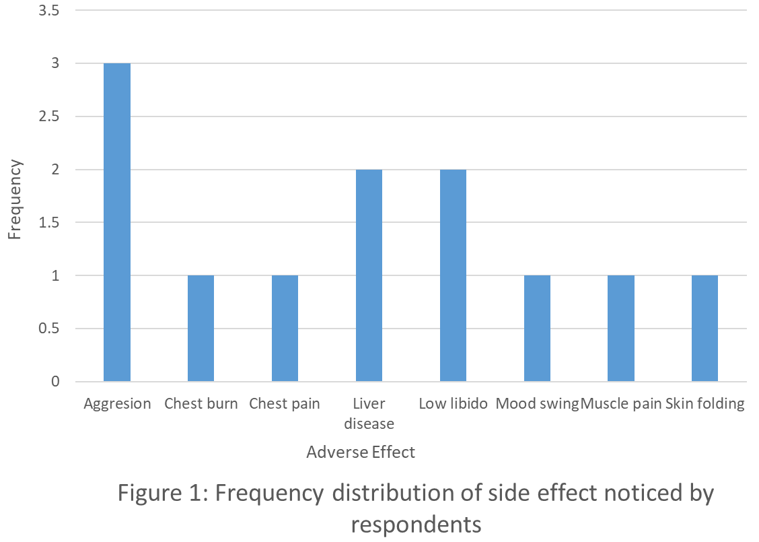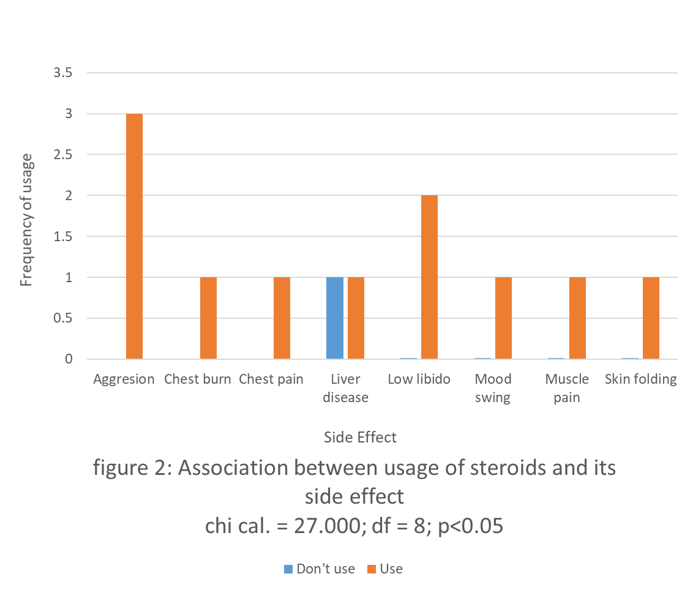

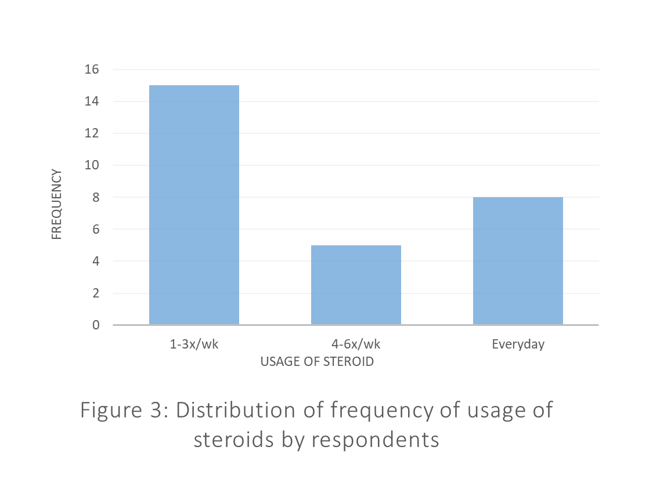

DISCUSSION
The awareness of steroid use and its adverse effects among athletes all over the world is of major concern to the health of these athletes and to the sporting world at large.
From our study, 84.7% of steroids users were males while 15.3% were females, thus corroborates with another study that showed male preponderance to females (O’connor et al. 2004; Bahri 2017; Uddin et al. 2019). Younger adults between the ages of 18-25 years constituting 62.4% when grouped were noted to be more involved with the usage of steroids to develop their muscles not minding the adverse effects that comes with its use. Nevertheless, this age group cuts across both sexes. Elliot and Goldberg (2000) noted similar age group of young adults involved in illicit steroid use. The possible reasons for this is been attributed to the higher number of this age group in sporting activities especially competitive sporting events than other age groups. Although the level of awareness of steroid use is relatively high (85%), most of the participants are unaware of the adverse effects that accompanies its usage. Again they are unaware of the withdrawal symptoms that comes up following stoppage of steroid consumption.
The present study recorded a 42.85% of steroid users who are willing to continue using it despite the harmful effects and complications. The adverse effects noticed by the respondents on wrong use of steroids includes liver disease 2 (16.7%) as indicated by elevated liver enzymes. Friedl (2000) and Snyder (2001) noticed similar conditions such as hepatic dysfunctions and elevations in levels of liver enzymes respectively. Two (2) respondents (16.7%) experienced chest pain and chest burns (1 each) though could not tell whether they were hypertensive or had other cardiovascular problems.
Muscle pains and skin folding were also noticed; 1 (8.3%) each by respondents as Battista et al. (2003) reported an increase in musculotendinous injuries with steroid use. Low Libido was noticed in another 2 subjects (16.7%) hence embracing similar documentation by Snyder 2001 that noticed altered sexual characteristics following prolonged steroid consumption.
The present study found that 33.3% of respondents developed psychological effects in the form of aggression and mood swings. Though this is low compared to the 90% reported by Tamir (2004) on steroid users showing aggressive and violent behaviours.
Hall and Hall (2005), in their review, suggested that anabolic steroid abuse has become a major problem in the United States, with more than 1 million individuals abusing these drugs. Another study conducted among health club users in the South Wales area revealed that AAS use is prevalent (70 %) among recreational gym users (Baker et al. 2006; Usman et al. 2015). The prevalence of AAS use among adolescents reported lifetime prevalence ranging from 1 % to 5 % (Thiblin and Petersson 2005; Zafar et al. 2018). The number of gym users taking anabolic steroids is steadily increasing in Nigeria just as it is in the Middle East where the use of AAS ranges from 4.2% to 26 % of bodybuilders are reportedly using anabolic steroids (Nojoomi and Behravan, 2003; Tahtamouni et al. 2008; Alsaeed et al. 2015).
Generally, a proper public education and enlightenment is required so as to control and subsequently stop the wrong use of steroids by mesomorphic athletes. Therefore, there is need for proper review and awareness for steroid users to prevent numerous adverse health effects as unearthed in this research. The present study found that use and abuse of steroids is prevalent in young males who have little or no level of awareness on the adverse effects of steroid use among mesomorphic athletes in Calabar metropolis.

REFERENCES
Alsaeed I, Alabkal JR. Usage and perceptions of anabolic-androgenic steroids among male fitness centre attendees in Kuwait-a cross-sectional study. Subst Abuse Treat Prev Policy. 2015 Aug 22;10(1):1.
Bahri, A., Mahfouz, M. S., Marran, N. M., Dighriri, Y. H., Alessa, H. S., Khwaji, M. O., & Zafar, S. M. (2017). Prevalence and awareness of anabolic androgenic steroid use among male body builders in Jazan, Saudi Arabia. Tropical Journal of Pharmaceutical Research, 16(6), 1425-1430.
Baker JS, Graham MR, Davies B. Steroid and prescription medicine abuse in the health and fitness community: A regional study. Eur J Intern Med. 2006; 17(7):479-84.
Battista, V., Combs, J., Warne, W.J., 2003. Asynchronous bilateral Achilles tendon ruptures and androstenediol use. American Journal of Sports Medicine. 31, 1007–1009.
D’Andrea A, Caso P, Salerno G, Scarafile R, De Corato G, Mita C, Di Salvo G, Severino S, Cuomo S, Liccardo B, Esposito N. Left ventricular early myocardial dysfunction after chronic misuse of anabolic androgenic steroids: a Doppler myocardial and strain imaging analysis. Br J Sports Med. 2007; 41(3):149-55.
Elliot D. L., Goldberg L. (2000). Women and anabolic steroids. In Yesalis C. E. (Ed.), Anabolic steroids in sport and exercise (2nd ed., pp. 225-246). Champaign, IL: Human Kinetics.
Eskandarion, M., Kheirvari Khezerloo, J., Hemmatian, S., Tabasi, M., & Ghorbani, R. (2019). Prevalence of Anabolic Steroids among the Male Bodybuilding Athletes and Rate of Awareness to Side Effects in Shahrud. Iranian Journal of Forensic Medicine, 25(1), 1-7.
Fink, J., Schoenfeld, B. J., Hackney, A. C., Matsumoto, M., Maekawa, T., Nakazato, K., & Horie, S. (2019). Anabolic-androgenic steroids: procurement and administration practices of doping athletes. The Physician and Sportsmedicine, 47(1), 10-14.
Friedl, K.E., 2000. Effect of anabolic steroids on physical health. In: Yesalis, C.E. (Ed.), Anabolic Steroids in Sport and Exercise, second. Human Kinetics, Champaign, pp. 175–225.
Hall RC, Hall RC. Abuse of supraphysiologic doses of anabolic steroids. South Med J. 2005; 98(5):550-5.
Hussain, B., Khalily, M. T., Rehman, A. U., Masud, M., & Arouj, K. (2019). Prevalence of anabolic androgenic steroids usage among Pakistani athletes and its psychological/legal consequences. The Shield-Research Journal of Physical Education & Sports Science., 13.
Kasikcioglu E, Oflaz H, Umman B, Bugra Z. Androgenic anabolic steroids also impair right ventricular function. Int J Cardiol. 2009; 134(1):123-5.
Nojoomi M, Behravan V. Study of anabolic steroids and the awareness of their complications in bodybuilding athletes in Karaj (2003). Razi Journal of Medical Sciences. 2005 Mar 15;11(44):1057-63.
Nussey S; Whitehead S (2001). Endocrinology: An Integrated Approach. Oxford: Bios Scientific Publ. ISBN 978-1-185996-252-7.
O’Connor, D.B., Archer, J., Wu, F.C., 2004. Effects of testosterone on mood, aggression, and sexual behavior in young men: a double-blind, placebocontrolled, cross-over study. J. Clin. Endocrinol. Metab. 89, 2837–2845.
Perry MC, Doll DC, Freter (2012). Perry’s The Chemotherapy Source Book. Lippincott Williams & Wilkins. pp 409-. ISBN 978-1-4698-0343-2.
Powers M (2011). Houglum J, Harrelson Gl (eds.) Performance- Enhancing Drugs. Principles of Pharmacology for Athletic Trainers (2nded.). SLACKK Incorporated. P. 345. ISBN 978-1-55642-901-9.
Snyder, P.J., 2001. Androgens. In: Hardman Limbird, J.G.L.E., Goodman Gilman, A. (Eds.), The pharmacological Basis of Therapeutics, tenth ed. McGraw Hill, New York, pp. 1635– 1648.
Tahtamouni LH, Mustafa NH, Alfaouri AA, Hassan IM, Abdalla MY, Yasin SR. Prevalence and risk factors for anabolic-androgenic steroid abuse among Jordanian collegiate students and athletes. Eur J Public Health. 2008; 18(6):661-5.
Tamir, E., Ner, Y.Z., Dayan, Y., Tamir, D., 2004. Knowledge and attitude regarding use of anabolic steroids among youth exercising in fitness centers. Harefuah 143, 348–352.
Thiblin I, Petersson A. Pharmacoepidemiology of anabolic androgenic steroids: a review. Fundam Clin Pharmacol. 2005; 19(1):27-44.
Turrillazzi E, Perilli G, Di Paolo M, Neri M, Riezzo I, Fineschi V (2011). “side effects of AAS abuse: an overview” Mini Rev Med Chem. 11(5): 374-89.doi:10.2174/138955711795445925. PMID 21443513.
Uddin, Z., Iqbal, Q., Haider, S., & Saleem, F. (2019). Usage and perceptions of anabolic-androgenic steroids among male gym attendees in Calabar city, Pakistan–a descriptive analysis. Research in Pharmacy and Health Sciences, 5(2), 152-157.
Usman HB, Rashid F, Ayub H, Ayub A, Akram N, Walter S, et al. Knowledge, awareness and practices of harmful effects of anabolic steroids among body builders in Rawalpindi and Islamabad. Pak Armed Forces Med J 2015; 65(2): 282-5.
Vanberg P, atar D (2010). “androgenic anabolic steroid abuse and the cardiovascular system”. Handbook of Experimental Pharmacology. 195 (195): 411-57. doi: 10.1007/978 – 3-540-79088-4_18. ISBN 978-3-540-79087.PMID 20020375.
Zafar R, Waseem W, Akhtar S, Ahmad H, Akhtar H, Gul R. Weight Lifters Maltreatment of Anabolic Steroids in Twin Cities of Pakistan. RADS Journal of Pharmacy and Pharmaceutical Sciences 2018; 6(4): 217-22

