Original Paper
NEUROPROTECTIVE EFFECTS OF GARLIC SYNTHETIC COMPLEX IN SCOPOLAMINE INDUCED LEARNING AND MEMORY DEFICIT IN WISTAR RATS
Iteire K.A.¹, Ukwenya V.O*.², Elegbeleye D.A¹

- Anatomy Department, University of Basic Medical Sciences, Ondo City, Ondo, Ondo State
- Human Anatomy Department, Federal University of Technology Akure, Ondo State

*Correspondence author: Ukwenya V.O
Human Anatomy Department, Federal University of Technology Akure, Ondo State.
voukwenya@futa.edu.ng

Authors name and address:
- Dr Iteire Kingsley Afoke (PhD). Anatomy Department, University of Basic Medical Sciences, Ondo City, Ondo, Ondo State. aiteire@unimed.edu.ng
- Dr Ukwenya Victor Okoliko (PhD). Human Anatomy Department, Federal University of Technology Akure, Ondo State. voukwenya@futa.edu.ng
- Miss. Elegbeleye Deborah Anjolajsu (BSc). Anatomy Department, University of Basic Medical Sciences, Ondo City, Ondo, Ondo State. afokeone@gmail.com
Running Title: Itiere et al: Garlic effects on hippocampi deficits.

ABSTRACT
This study was undertaken to evaluate the neuroprotective role of garlic synthetic complex (containing Allicin, Alliin and S-allylcysteine) in scopolamine-induced learning and memory deficit in rats. Fifty-six adult male wistar rats were assigned into seven groups (n=8). Groups 1, 2 and 4 received distilled water only, Scopolamine only, and 200mg/kg of garlic synthetic complex only, respectively. Groups 3, 5, 6 and 7 received donepezil (0.07mg/kg), 100mg/kg, 200mg/kg and 300mg/kg of the garlic synthetic complex, respectively. The effects on learning and memory and also locomotor activity were assessed via different behavioral tests. After fourteen days treatment, the animals were sacrificed, their brains harvested and hippocampi dissected out for examination. The effect of each treatment on the histoarchitecture of the hippocampi was histologically evaluated, brain AChE activity was also measured to evaluate the central cholinergic system, and MDA and SOD activity were measured to assess oxidative stress level. The results suggest significant hippocampal degeneration in rats receiving Scopolamine only compared to normal group, recovery of the hippocampal histoarchitecture in rats receiving doses of garlic synthetic complex, and absence of hippocampal degeneration in the normal and positive control groups. Garlic synthetic complex showed learning and memory enhancing and neuroprotective effects, these may be related to reduction in AChE and MDA activity, and increased SOD activity in their hippocampi.
Keywords: Allicin, Alliin, S-allylcysteine, Hippocampus, Learning and Memory.

INTRODUCTION
Learning and memory are the most fundamental and nearly related processes occurring in the brain (Radvansky, 2017). Memory is one of the vital abilities of individuals to take record of their experiences, preserve the information to adapt their responses to the environment, and retain them over both short and long periods of time. Learning is basically the process of acquiring memory (Rajangam, 2018). Amnesia which presents in Alzheimer’s disease, is majorly characterized by loss of memory, interfering with one’s normal activities; it is one of the common causes of dementia, a progressive neurodegenerative disorder associated with loss of neurons in distinct areas of the brain (Rajangam, 2018). Scopolamine, an anticholinergic drug, can block acetylcholine receptors and lead to a significant increase of acetylcholinesterase level in the hippocampus and cortex (Gil-Yong, et al., 2017). Scopolamine can also increase the accumulation of reactive oxygen species that induce oxidative stress within the brain, leading to brain cell death, and automatically, memory impairment (Fanta et al., 2020).
Moreover, oxidative stress has been proven to lead to cell death via apoptosis and degeneration of cholinergic nervous system, which result in cognitive and memory impairment (Xu et al., 2016). Therefore, protecting cholinergic system from functional degeneration and the presence of antioxidants might be serviceable against scopolamine-induced amnesia (Fanta et al., 2020).
Donepezil is an enzyme blocker that inhibits acetylcholinesterase (AchE), by restoring the balance of the neurotransmitter acetylcholine in the brain. It does not cure Alzheimer’s disease, but it may improve memory, awareness, learning and ability to function. Donepezil may help compensate for the loss of functioning cholinergic brain cells due to neurodegeneration (Knowles, 2006).
Garlic (Allium sativum) has been widely investigated for its health benefits based on its different powerful effects; it is considered as one of the best disease preventive foods. Several studies have demonstrated the antioxidant properties of garlic and its different preparations including Aged Garlic Extract (AGE) and S-allylcysteine (SAC), a bioactive and bioavailable component in garlic preparations have been shown in a number of in vitro studies to protect neuronal cells against beta-amyloid (Aβ) toxicity and apoptosis. Thus, the broad range of anti-atherogenic, antioxidant and anti-apoptotic protection afforded by garlic may be extended to its neuroprotective action, helping to reduce the risk of dementia, including vascular dementia and AD (Farooqui & Farooqui, 2018). Hence, this study aimed to investigate the differential effects of garlic synthetic complex in experimental neurotoxicity.

MATERIALS AND METHODS

Ethical Considerations
All procedures involving animals in this study conformed to the guiding principles for research involving animals as recommended by the declaration of Helsinki and the guiding principles in the care and use of animals (National Research Council, 2011) and were approved by the Departmental Committee on the use and care of animals.

Experimental Animals
A total of 56 male wistar rats (210 + 40g) were obtained from the Animal House in the University of Medical Sciences, Ondo. Animals were maintained under standard environmental conditions (12:12 hour light-dark cycle) at the Animal House. All animals had free access to standard feed and water ad libitum. The experiments were performed to minimize animal suffering in accordance with the internationally accepted principles for laboratory animal use and care, as found in the European community guidelines (ECC Directive of 1986;86/609/ECC).

Experimental Design
All male albino Wistar rats were randomly assigned to seven groups of eight animals each. Group 1 was used for normal control, receiving only water orally. Group 2 was used for negative control, where the rats received distilled water and Scopolamine. Group 3 served as positive control which was given Donepezil, and Scopolamine. Group 4 animals were given the garlic synthetic complex, AAS (200mg/kg) only. Groups 5,6 and 7 served as the test groups which received AAS (100mg/kg, 200mg/kg and 300mg/kg respectively) orally, and after 30minutes, Scopolamine (1mg/kg) was administered intraperitoneally. All the dozing was done for a period of 14 days. Behavioral studies such as Y-Maze Test and Novel Object Recognition Test, Open field Test and Elevated Plus Maze Test were carried out on day 7 to monitor the effects of the drugs and on day 14 before they were sacrificed.

Preparation of Drugs Used
200mg of Scopolamine hydrobromide was diluted in 1litre of boiling water, making a working concentration of 0.2mg/ml and it was administered at a standard dose of 1mg/kg.
5mg of Donepezil Hydrochloride was diluted in 100ml of water to make a working concentration of 0.05mg/ml, and it as administered at 0.07mg/kg.
Garlic Synthetic Complex containing Allin, Allicin and S-allylcysteine at doses of AAS 100mg/kg p.o , 200mg/kg p.o and 300mg/kg p.o respectively.

Method of Induction of Learning and Memory Impairment
Scopolamine is used to model cognitive dysfunction and learning and memory impairment in normal, healthy rats. Scopolamine was administered using an insulin syringe and it was injected intraperitoneally.

Preparation of Subcellular Fractions.
The animals were sacrificed with their brains (hippocampus) obtained for analysis, harvested brains were quickly excised, rinsed in normal saline, stored in a plain tube and weighed. The hippocampus was quickly dissected from brain for examination. They were homogenized with phosphate buffer.

Acetylcholinesterase (AchE) Actvity
The amount of acetylcholinesterase was estimated by the method described by Ellman. For the estimation of the acetylcholinesterase activity, 20 μl of 0.1M Tris-HCl buffer (pH8.0) is introduced, 3 ml of Ellman’s reagent (DTNB) in alltubes (blank and assays), and 100 μl of brain homogenate in test tubes. After rapid homogenization at room temperature, the absorbance was read at 412nm after 30 sec and 90 sec against the blank.

Antioxidant Assay for Hippocampal Damage.

Superoxide Dismutase (SOD) Activity
Superoxide dismutase (SOD) is an intracellular enzyme that converts superoxide radicals into hydrogen peroxide and molecular oxygen. Its activity is determined by its ability to inhibit the auto-oxidation of epinephrine at pH 10.2 monitored by the increase in absorbable at 480nm as described by Misra and Fridovich in 1972. The tissues were homogenized to physiological saline (1:4 tissues to homogenate) using a homogenizer and centrifuged at 4000g for 20. SOD activity was measured using the method based on nitroblue tetrazolium reduction rate. One unit of SOD activity was expressed as the amount of enxyme that causes 50% inhibition in the nitroblue tetrazolium reaction rate (Durak et al., 1996).

Malondialdehyde (MDA) Activity
An MDA assay was performed according to the protocol described by Wilbur et al. (1943) with some modifications. For this assay, 500 ml of homogenate was introduced in the test tubes and 500 μl of Tris-HCl buffer (50 mM, pH 7,4) in the control tube. In each tube, 250 ml of trichloroacetic acid (TCA) 20% and 500 μl of TBA 0.67% were added. The tubes were closed with glass beads and then incubated in water bath for 10 min at 90°C.They were then left in room temperature for cooling before being centrifuged at 3000 rpm for 15 minutes. The supernatant was piped, and the absorbance was read with a spectrophotometer at 530nm against the control. The concentration of MDA in mol/g was determined using the formula of Beer-Lambert using the molar extinction coefficient 1:56 × 105mmol-1cm-1 (Ohkawa et al., 1979).

Evaluation of Memory Performance

Y-Maze test.
One hour after treatment with Distilled water (1mg/kg, p.o), Donepezil (1mg/kg, p.o), s-allylcysteine (100mg/kg, 200mg/kg and 300mg/kg, p.o), Rats (n=8) per cage were subjected to Y-Maze test for 5 minutes. The percentage alternation, which is a measure of spatial memory, was calculated as: (Total alternation number/Total number of entries-2) x 100. Alternation behavior was defined as consecutive entries into three arms (i.e ABC, CAB, or BCA, but not BAB) and the maze was cleaned with 70% ethanol after each test to prevent residual colour (Kraeuter, 2019).

Novel Object Recognition Test (NORT)
This test consists of the trial and test phases. In the trial phase, Object A and B of identical sizes were placed in the open field chamber (60cm x 50cm x 40cm) at a distance of 8cm from the walls and 34cm from each other on opposite sides and the rats were placed individually in the middle of the two objects for 5minutes. The animals (n=8) were then returned into their home cages. The 24 hours later, the test phase, which involved the replacement of objects B with C that was novel to the animals, was carried out. The animals were then allowed to explore the objects A and C for 5 minutes. The time spent (in seconds) in exploring the objects (the number of exploring familiar object, N1; the number of exploring the novel object, N2) was recorded in both phases. The discrimination index, a measure of non-spatial memory, was calculated as the difference in time spent in exploring the novel and familiar object divided by the total amount of time spent with both objects (Tatem et al., 2014).

Open Field Test.
This represents a new stressful environment for the animal and allows for evaluation of locomotor activity, level of exploration, and emotional response in animals, in a single day. Animals that received Scopolamine and were analyzed for memory in the Y-maze were immediately placed in the open field. The following parameters were noted for a period of 5minutes for each mouse: the number of “crossing” (number of crossed lines or crossed tiles), the number of “rearing” (when the animal is placed on its hind legs by resting on the wall of the device with its front legs), and the time spent in the centre square (Tatem et al., 2014).

Elevated Plus Maze (EPM) Test.
Elevated plus was used as an exteroceptive behavioral model to evaluate both acquisition and retention of memory in the rats. The elevated plus maze had two open arms (16 cm × 5 cm) and two covered arms (16 cm × 5 cm× 12 cm) extended from a central platform (5 cm × 5 cm) and was elevated to a height of 25 cm from the floor. On the seventh and fourteenth days of administration, the Transfer latency (TL) which is the time taken by the rats to move from open arm to closed arm with all four legs in elevated plus maze was noted. The rat was allowed to explore the maze for another 2 min and then allowed to return to its home cage. After 24 hours of acquisition trial, TL was again noted as an index of retrieval (Kraeuter, 2019).

Statistical Analysis.
Data were analyzed using GraphPadPrism software version 9.4.3. The data was presented as the mean + SD (n=4). For normally distributed data, comparison among the different studied groups was done using One-way ANOVA followed by the Durnett’s multiple comparison test. The Scopolamine group was analyzed compared to the control group, and the groups receiving AAS and receiving Donepezil were compared to the Scopolamine group. The difference was taken to be statistically significant at p < 0:05.

Tissue Processing
The tissues were observed and cut into small pieces of not more than 4mm thick into pre-labeled cassettes. These were further processed for histological evaluation as previously described by Ukwenya et al. (2013). The slides were then stained with hematoxylin and eosin (H&E) and Masson Trichrome stains, mounted in DPX and photomicrographs were taken at a magnification of X100 on OMAX microscope (USA).

RESULTS
Behavioral Tests

Y-maze test
The effects of the garlic extracts, AAS on spatial memory (which is a type of short-term memory) function on the rats was evaluated using Y-maze task.
Figure 1a: Y-Maze test, showing effect of AAS on the percentage alternation of rats in experimental groups.
Keys: *, **- Mean values are significantly different (p < 0.05, p < 0.01) when compared to scopolamine treated group. ns- Mean value not significantly different when compared to scopolamine treated group.
As shown in figure 1a above, the group treated with scopolamine only shows a significant (p < 0.005) decrease in % alternation when compared to the vehicle, while the administration of donepezil + scopolamine, AAS only, AAS200 and AAS300 all caused a significant (p < 0.05, p < 0.001, p < 0.05, p < 0.01 respectively) increase in the percentage alternation when compared to the Scopolamine treated rats. However, group treated with AAS (100mg/kg) showed no significance (p > 0.5) when compared with the scopolamine treated group.
Figure 1b: Y-Maze test, showing effect of AAS on the total number of arm entries made by rats in experimental groups.
According to the figure 1b, the rats in control group, rats treated with different doses of AAS, and with donepezil demonstrated an increase in the number of entries into the different arms of the Y-maze as compared to the rats treated with Scopolamine only which demonstrated lesser number of entries. However, using One-way ANOVA, there is no significant difference between the mean values of the number of entries of the various experimental groups.
Figure 1c: Y-Maze test, showing effect of AAS on the frequency of right and wrong alternations made by rats in experimental groups.
From figure 1c, in the group of rats receiving Scopolamine only, the frequency of wrong alternations made is higher than the frequency of right alternations made. The groups receiving the different doses of AAS had a higher mean of frequency of right alternations, compared to the group treated with Scopolamine only. Although, based on One-way ANOVA analysis, the values are not significantly different.

Novel Object Recognition Test (NORT)
The NORT was used to investigate the effects of the garlic extracts, AAS on the learning and short-term memory of the rats.
Figure 2a: Novel Object Recognition Test, showing the effect of AAS on the mean time rats in experimental groups spent exploring both familiar and novel objects.
Rats in the scopolamine-treated group spent almost equal or lesser time exploring the novel object, that the mean exploration time on both familiar and novel objects appears equal from the Figure 2a. Also from this figure, rats in the AAS groups spent more time exploring the novel object than exploring the familiar object, except rats in AAS (100mg/kg) group. Therefore, the high concentration of AAS can improve memory impairment in rats.
Figure 2b: Novel Object Recognition Test, showing the effect of AAS on the % discrimination of rats experimental groups
Keys: *, ** Mean values are significantly different (p < 0.05, p < 0.01) when compared to scopolamine treated group. ns- Mean value not significantly different when compared to scopolamine treated group.
From figure 2b, the group treated with scopolamine shows a significant (p < 0.005) decrease in % discrimination when compared to the control group. The administration of donepezil + scopolamine, AAS only, AAS200 and AAS300 also all caused a significant (p < 0.01, p < 0.005, p < 0.05, p < 0.05 respectively) increase in the % discrimination when compared to the Scopolamine treated rats. However, group treated with AAS (100mg/kg) showed no significant (p > 0.5) difference when compared with the scopolamine treated group.

Open Field Test
Figure 3a: Open Field Test, showing the effect of AAS on the locomotion activity by number of line crossings of rats in experimental groups.
Keys: **- Mean values are significantly different (p < 0.005) when compared to scopolamine treated group. ****- Mean values are significantly (p < 0.0001) different when compared to scopolamine treated group
Figure 3a shows a significant increase (p < 0.005) of the of the locomotor activity by the number of line crossing in the rats receiving doses of AAS and receiving Donepezil compared to the Scopolamine group. The number of line crossing of the Scopolamine group significantly (p < 0.005) decreased compared to the control group.
Figure 3b: Open Field Test, showing the effect of AAS on the locomotion activity by number of rearing of rats in experimental groups.
*- Mean values are significantly different (p < 0.05) when compared to scopolamine group. **- Mean values are significantly different (p < 0.005) when compared to scopolamine treated group.
Figure 3b shows a significant increase (p < 0.005) in the rearing activity in the animals receiving different doses of AAS and receiving Donepezil (p < 0.05) contrary to the Scopolamine group that significantly decreases (p < 0.005).
Figure 3c: Open Field Test, showing the effect of AAS on the locomotion activity by duration in the centre square by rats experimental groups.
Keys: *- Mean values are significantly different (p < 0.05) when compared to scopolamine group. **- Mean values are significantly different (p < 0.005) when compared to scopolamine treated group. ***- Mean values are significantly different (p < 0.001). ns- Mean values are not significantly different (p > 0.05) when compared to scopolamine treated group.
The time spent in the centre of the open field decreased significantly in animals given Scopolamine (p < 0.001) compared to the control group, but an increase of this time was observed in the animals treated with AAS only (p < 0.005), AAS 200mg/kg and AAS 300mg/kg (p < 0.05). However, rats in AAS 100mg/kg and Donepezil + Scopolamine group showed no significant difference (p > 0.05) when compared to the Scopolamine group (Figure 3c).

Elevated Plus Maze (EPM) Test
The EPM test was used to evaluate the effects of the garlic extracts, on acquisition and retention memory in rats.
Figure 4: Elevated Plus Maze Test, showing the effect of AAS on both acquisition of memory (learning) and retention of memory of rats in experimental groups.
The transfer latency of the animals decreased on the second day after 24hours of training on the elevated plus maze. According to the figure 5, the scopolamine-treated group showed a significant increase in the TL of rats compared to the control group. Administration of AAS only, AAS100mg/kg and Donepezil+Scopolamine did not show any significant difference (p > 0.05) in the TL of rats on the 1st and 2nd days compared to the Scopolamine group. The rats receiving AAS 200mg/kg and 300mg/kg showed a significant increase in the TL of rats on the 1st and 2nd days compared to the Scopolamine group (p < 0.05). (Figure 4).

Acetylcholinesterase Activity
Figure 5: Effect of AAS on the acetylcholinesterase activity in the hippocampus of rats in experimental groups.
Value represent Mean ± SD (n=3). Keys: *, **- Mean values are significantly different (p < 0.05; p < 0.01) compared with the scopolamine only group. ns- Mean values are not significantly different compared with the scopolamine only group.
From figure 5, the control group shows a significant decrease in AChE activity (p < 0.05) when compared with the scopolamine group. Administration of the doses of AAS and Donepezil showed a significant decrease in AChE activity when compared with the scopolamine only group. However, administration of the low dose of AAS (100mg/kg) caused no significant difference in AChE activity when compared with the scopolamine only group.

Malondialdehyde (MDA) Activity
Figure 6: Effects of AAS on MDA activity in the hippocampus of rats in experimental groups.
Administration of Donepezil + Scopolamine and all different doses of AAS caused no significant difference (p > 0.05) in the level of MDA activity in the hippocampus of the rats.

Superoxide Dismutase (SOD) Activity
Figure 7: Effects of AAS on SOD activity in the hippocampus of rats in experimental groups.
Each bar represents the Mean ± SD (n=3). Keys: *, **- Mean values are significantly different (p < 0.05; p < 0.01) compared with the scopolamine only group. ns- Mean values are not significantly different compared with the scopolamine only group.

Histological Demonstration of Hippocampal Damage among Experimental Groups

CA1 REGION (× 40)
NORMAL
SCOPOLAMINE
AAS ONLY
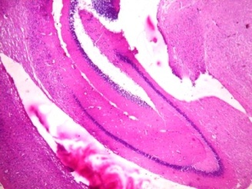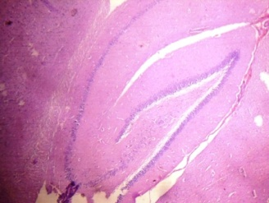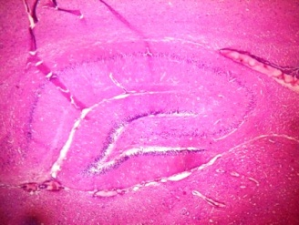
DONE+SCOP
AAS 200+SCOP
AAS 100+SCOP
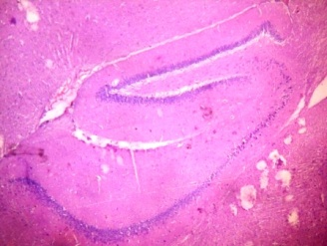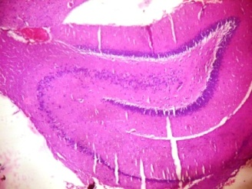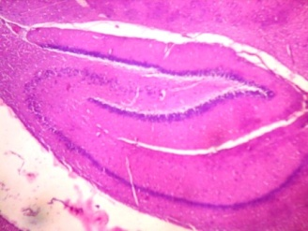
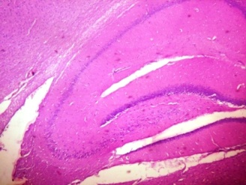
AAS 300+SCOP

Figure 8: Photomicrograph (× 40) of Haematoxylin and Eosin staining of the Hippocampal CA1 region of all treatment groups.
The structural organization of the CA1 region in all treatment groups seen appear normal (white arrow).

CA2 REGION (× 100)
AAS ONLY
SCOPOLAMINE
NORMAL
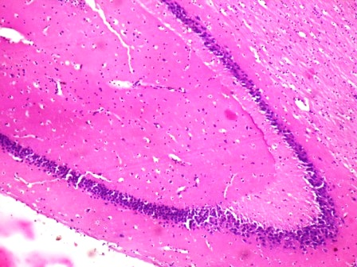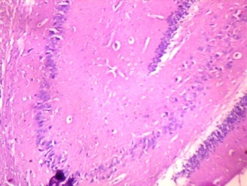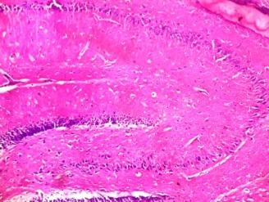
DONE+SCOP
AAS 200+SCOP
AAS 100+SCOP
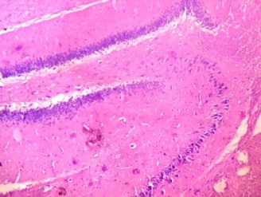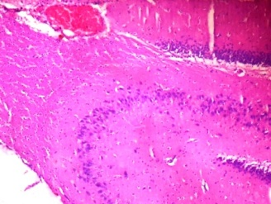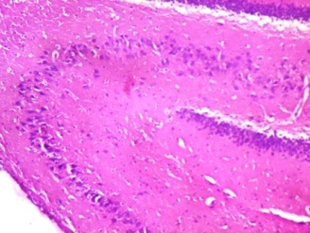
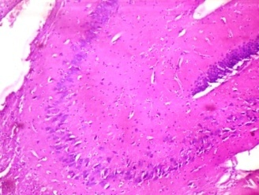
AAS 300+SCOP

Figure 9: Photomicrograph (× 100) of Haematoxylin and Eosin staining of the Hippocampal CA2 region of all treatment groups.
The structural organization of the CA2 region in all treatment groups seen appear normal (white arrow).

CA3 REGION (× 400)
AAS ONLY
NORMAL
SCOPOLAMINE
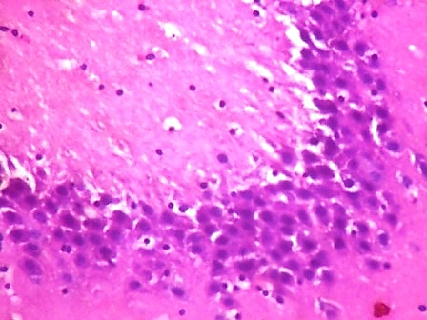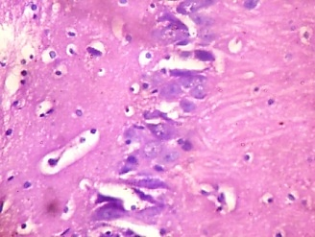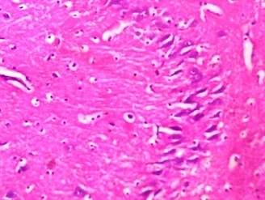
AAS 200+SCOP
DONE+SCOP
AAS 100+SCOP
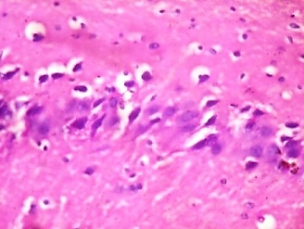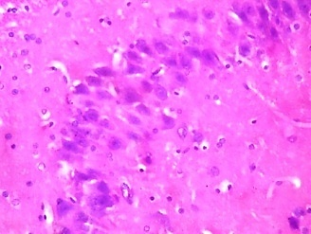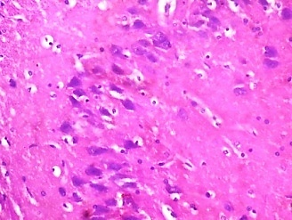
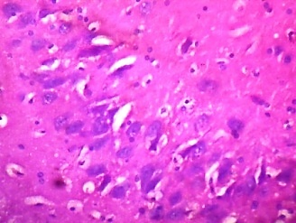
AAS 300+SCOP

Figure 10: Photomicrograph (×400) of Haematoxylin and Eosin staining of the Hippocampal CA3 region of all treatment groups.
From the histological evaluations, all experimental groups except the scopolamine-treated group show normal hippocampus with normal neuronal cells, the structural organization of CA3 seen appears normal (blue arrow). However, the hippocampus of animal in the scopolamine-treated group shows depleted neuronal cells and poor organization at CA3 (blue arrow). (Figure 8,9,10).

Discussion
The present study was undertaken to investigate the neuroprotective effects of garlic extracts (allicin, allin, s-allylcysteine) by improving learning and memory impairment. Medicinal plants have been playing a very significant role in the management of Alzheimer's disease and other memory related health issues. In this study, the effects of garlic extracts, AAS on the learning and memory function of the amnesic rats were evaluated using Y-maze, open field, elevated plus maze, and novel object recognition tests. These behavioral tests are useful for studying learning and short-term memory processes by manipulating the retention interval (Min et al., 2010). In previous studies, scopolamine-treated animals showed a lower discrimination index in the NORT, a higher transfer latency in the elevated plus-maze test, reduced number of crossings, rearing and centre square duration in the open field test, and a reduced % alternation in the Ymaze test. Scopolamine promoted amnesia in the animals through impaired learning and memory, by inducing oxidative stress in the brain and also by blocking the muscarinic cholinergic receptor as earlier reported (Gil-Yong et al., 2017; Fanta et al., 2020).
The open field test is normally used to evaluate exploration behaviour and also locomotor activity of rats in response to a new environment (Botton et al., 2020). The rats treated with Scopolamine (1 mg/kg) demonstrated a reduced number of crossing and rearing resulting in Scopolamine-altered locomotion activity. In this test, the increase in the number of line crossing, the number of rearing, and the time spent in the centre for the group of rats treated with the different doses of AAS indicates an increase of exploration and locomotor activity, although rats treated with the low dose (100mg/kg) of AAS spent lesser time in the centre square. However, it is still possible to suggest that garlic extracts, AAS have memory improving properties, which could also be mediated by cholinergic neurotransmission at the level of the hippocampus (Botton et al., 2020).
The novel object recognition test has been used extensively in the studies of behavior and brain functions in rats and mice in the study of memory and neuroscience generally (Ennaceur et al., 2009; Pahaye et al., 2017). The results of the object recognition test showed that Scopolamine decreased the object exploration time, especially time spent exploring the novel object. It also significantly decreased the percentage discrimination in the group of the rats that received Scopolamine, and this suggests an impairment of both learning and recognition (short-term memory) process. Hence, Scopolamine an anticholinergic agent blocks muscarinic receptors, thereby decreasing learning and memory performance in humans and animals as reported by Takeuchi (2015).
The elevated plus maze test has been considered as an indicator of short-term memory. In this study, scopolamine-treated rats showed a significant decrease in the transfer latencies on the first (acquisition) and second (retention) rats trial days, which could be significantly attenuated by pretreatment with the standard (200mg/kg) dose and high dose (300mg/kg dose) of AAS.
The reduction of spontaneous alternation in the Y-maze test is known to represent short term memory in mice and rats. In the Y-maze test in this present study, AAS administration (200mg/kg and 300mg/kg) significantly increased the percentage alternation in the rats, contrary to the decreased alternation that was induced by scopolamine. Also, rats that received AAS only, demonstrated the highest number of entries into the different arms of the Y-maze, while the lowest number of entries into the arms was demonstrated by the Scopolamine treated group. Other rats that received distilled water only, the different doses of AAS, and donepezil all had a higher mean number of entries, compared to the group treated with scopolamine. In the group of rats receiving Scopolamine only, the frequency of wrong alternations made is higher than the frequency of right alternations made. The groups receiving the different doses of AAS had a higher mean of frequency of right alternations, compared to the group treated with Scopolamine only. Although, based on One-way ANOVA analysis, the values are not significantly different. Overall, the results of the Y-maze test are back up by different studies that have been conducted and have proven that the bioactive compounds present in garlic have the ability to improve spatial recognition memory in memory impaired rats (Yoshizaki et al., 2020).
In this study, Hematoxylin and Eosin staining was used to histologically assess the histoarchitecture of the hippocampus. The photomicrographs of the results show that the administration of Scopolamine caused depletion of neuronal cells in CA3 region of all hippocampi examined, indicating neuronal cell death (apoptosis) in neurodegeneration, although the structural organization of CA1 and CA2 appear normal as in other groups. Not only did Scopolamine cause depletion of the neuronal cells, an area of mild hemorrhage was also seen in the CA3 region, this could be due to neuroinflammation or traumatic brain injury. These data suggest that the neurotoxicity of Scopolamine in the hippocampus may be partially due to its facilitation of apoptosis. Groups treated with different doses of AAS, the normal group, and group treated with donepezil all showed normal neuronal cells and normal structural organization in CA1, CA2 and CA3 regions. This data suggests that higher doses of AAS were able to prevent or protect the hippocampus from scopolamine-induced neurotoxicity and neurodegeneration.
Scopolamine-induced memory disorders are also associated with increased oxidative stress in the brain, characterized an increase in Malondialdehyde (MDA) activity, a harmful effect of reactive oxygen species (ROS). Increased MDA level has been shown to be an important marker for in vivo lipid peroxidation, and because the brain is composed of lipids, this may directly lead to brain death (Fanta et al., 2020). The major antioxidant and oxidative free scavenging enzymes like SOD play an important role in reducing oxidative stress in the brain. The results of this present study showed a decline in the brain's antioxidant defense system characterized by a higher MDA level and a lower SOD activity in the Scopolamine treated group as suggested earlier by Lee et. al. (2015) However, in this study, treatment with the low (100mg/kg) and standard (200mg/kg) doses of AAS showed no significant increase in the SOD activity, but the rats in the group that received the high dose (300mg/kg) showed a significant increase.
The central cholinergic system plays a very important role in the processes of learning, memory and other cognitive functions. Cognitive deficiencies in the elderly are most times due to dysfunction of neurons that contain acetylcholine. The results of this study are in line with Chen et al., who earlier reported that Scopolamine produces severe cholinergic deficits and increase in hippocampal acetylcholinesterase activity, enhancing neurodegeneration. In this study, treatment with the standard (200mg/kg) and high (300mg/kg) doses of garlic extracts, AAS significantly reduced the activity of acetylcholinesterase compared to Scopolamine group, but treatment with the low (100mg/kg) dose caused no significant difference in the AChE activity as compared to the Scopolamine group. This result is constituent with a recent study by Yadang et al. in 2018, where the hydroethanolic extract decreased the activity of AChE and enhanced the memory in different cognitive impairment models. It is also consistent with an earlier study by Fanta et el. in 2020, where C. edulis extract significantly reduced AChE activity. Thus, these data suggest that the memory enhancement effects of AAS especially in groups receiving the higher doses can be due to the inhibition of acetylcholinesterase activity and increased acetylcholine release into the synaptic gap.
Lastly, during this study, the rats that receiving the different doses of AAS showed signs of diarrhea and edema on their paws, these are believed to be the side effects or allergies from garlic consumption. Allergies such as irritable bowel, diarrhea, mouth and throat ulceration, nausea and anaphylaxis have been associated with consumption of garlic and other species of Allium (Block, 1985). According to a study conducted by Augusti in 1996, on the therapeutic values of onion (allium cepa L.) and garlic (allium sativum L.), he claimed that a large amount of garlic consumption can result in undesirable side effects such as diarrhea. The edema on the paws of the rats is suggested to be as a result of garlic consumption, resulting in decreased blood pressure. A study by Borrelli et al., 2007, showed that angioedema, anaphylaxis, allergic contact dermatitis, generalized urticarial, and photoallergy are possible allergic reactions from garlic use. Banerjee and Maulik (2002) also suggested that the gamma-glutamylcysteines compounds present in garlic, may lower blood pressure due to their ability to inhibit angiotensin-converting enzyme in in vitro.

Conclusion
This present study was conducted to evaluate the effects of garlic extracts (Allicin, Alliin, and S-allylcysteine) on Scopolamine-induced learning and memory impairment in rats. Scopolamine-induced memory and learning deficits evaluated during the behavioral studies in Y-maze, Novel Object Recognition, Elevated Plus Maze, and Open field tests induced an increase in AChE and MDA activity and also a reduction in SOD activity. The administration of garlic extracts AAS significantly improved learning and memory functions in the rats as demonstrated in the behavioral studies, it also has potential neuroprotective effects as shown in the antioxidant defense system (increased SOD activity), thus protecting neurons from oxidative stress. It also showed protective effects on the cholinergic pathway, by reducing AChE level in the hippocampus. The histological study also showed that AAS was able to protect the general histoarchitecture of the hippocampus. Thus, the data presented in the study provides novel proof and supports the potential usefulness of garlic extracts, AAS in neuroprotection from learning and memory impairment.

REFERENCES
Augusti K. T. (1996). Therapeutic values of onion (Allium cepa L.) and garlic (Allium sativum L.). Indian journal of experimental biology, 34(7), 634–640.
Avwioro, G. (2014). Histochemistry and Tissue Pathology. Claverianun Press.
Banerjee, S. K., and Maulik, S. K. (2002). Effect of garlic on cardiovascular disorders: a review. Nutrition journal, 1, 4.
Block, E. (1985). The chemistry of garlic and onions. Scientific American. 252(3), 114-119.
Borrelli, F., Capasso, R., and Izzo, A. A. (2007). Garlic (Allium sativum L.): adverse effects and drug interactions in humans. Molecular nutrition and food research, 51(11), 1386–1397.
Botton P.H., Costa M. S., Ardais A. P. (2010). “Caffeine prevents disruption of memory consolidation in the inhibitory avoidance and novel object recognition tasks by Scopolamine in adult mice”. Behavioural Brain Research, 214(2), 254–259.
Cherry, K. (2021). Discovery and Functions of Acetylcholine. Verywell Mind.
Durak, I., Canbolat, O., Kavutçu, M., Oztürk, H. S., and Yurtarslani, Z. (1996). Activities of total, cytoplasmic, and mitochondrial superoxide dismutase enzymes in sera and pleural fluids from patients with lung cancer. Journal of clinical laboratory analysis, 10(1), 17–20.
Ennaceur A., Michalikovaa S., and Chazot P. (2009) “Do rats really express neophobia towards novel objects? Experimental evidence from exposure to novelty and to an object recognition task in an open space and an enclosed space”. Behavioural Brain Research (197), 417–434.
Fanta, S.A., Yvette N., Christelle, W.K., Patrick, H.D., Amina, M., Lauve R.Y., Germain S.T., Gabriel, A.A., & Elisabeth, N.B., (2020). Scopolamine-Induced Memory Impairment in Mice: Neuroprotective Effects of Carrisa edulis (Forssk.) Valh (Apocynaceae) Aqeous Extract. International Journal of Alzheimer’s Disease, 2020, 1-8.
Farooqui, T. & Farooqui A.A. (2018). "Neuroprotective Effects of Garlic in Model systems of Neurodegenerative Diseases". Role of Mediterranean Diet in the Brain and neurodegenerative diseases, 253-269.
Gil-Yong, L., Chan, L., Gyu, H.P., & Jung-Hee, J. (2017). Amelioration of Scopolamine-Induced Learning and Memory Impairment by Alpha-Pinene in C57BL/6 Mice. Evidence-Based Complementary and Alternative Medicine, 2017, 1-8.
Knowles J. (2006). Donepezil in Alzheimer's disease: an evidence-based review of its impact on clinical and economic outcomes. Core Evid. 1(3):195-219.
Kraeuter, A. K., Guest, P. C., & Sarnyai, Z. (2019). The Y-Maze for Assessment of Spatial Working and Reference Memory in Mice. Methods in molecular biology (Clifton, N.J.), 1916, 105–111.
Lee J. S., Kim H. G., Lee H. W.(2015) “Hippocampal memory enhancing activity of pine needle extract against Scopolamine induced amnesia in a mouse model,” Scientific reports, 5(1).
Misra HP, Fridovich I. (1972). The role of superoxide anion in the autoxidation of epinephrine and a simple assay for superoxide dismutase. J Biol Chem. 25;247(10):3170-5.
Ohkawa, H., Ohishi, N., and Yagi, K. (1979). Assay for lipid peroxides in animal tissues by thiobarbituric acid reaction. Analytical biochemistry, 95(2), 351–358.
Pahaye D. B., Bum E. N., Taïwé G. S. (2017). “Neuroprotective and antiamnesic effects of Mitragyna inermis Willd (Rubiaceae) on Scopolamine-induced memory impairment in mice,” Behavioural Neurology, 2017. ID 5952897, 11 pages.
Radvansky, G. A. (2017). Human Memory: Third Edition. Taylor and Francis.
Rajangam, J. & Lavanya, O. (2018). Effect of Rosuvastatin on learning and memory in scopolamine-induced amnesia in Mice. Trends in Medicine, 18, 1-4.
Takeuchi I, Suzuki T, Kishi T, Kanamori D, Hanya M, Uno J, Fujita K, Kamei H. (2015). Effect of Scopolamine Butylbromide on Clozapine-induced Hypersalivation in Schizophrenic Patients: A Case Series. Clin Psychopharmacol Neurosci.;13(1):109-12.
Tatem KS, Quinn JL, Phadke A, Yu Q, Gordish-Dressman H, Nagaraju K. (2014). Behavioral and locomotor measurements using an open field activity monitoring system for skeletal muscle diseases. J Vis Exp. 29;(91):51785.
Wilbur K M, Bernheim F and Shapiro O W. (1943). The TBARs reagent as a test for the oxidation of unsaturated fatty acids by various agents. Arch.Biochem Bioph; 24: 305 – 313.
Xu Q., Xu Y., Yang C., Tang Y., Li L. (2016). "Sodium Tanshinone IIA Sulfonate Attenuates Scopolamine Induces Cognitive Dysfunctions via Improving Cholinergic System". BioMed Research International, 2016, ID 9852536, 9 pages.
Yadang S. A. F., Taiwé G. S., Hadidjatou D., Nguezeye Y., & Ngo Bum E. (2018) “Effect of hydro ethanolic extract of Carissa edulis (Apocynaceae) on cognitive impairment induced by sleep deprivation”. in Conference: 46eme Congrès de la Société Francophone de Chronobiologie, Rabat, Morocco.
Yoshizaki, K. Asai, M. Hara, T. (2020). High-Fat Diet Enhances Working Memory in the Y-Maze Test in Male C57BL/6J Mice with Less Anxiety in the Elevated Plus Maze Test. Nutrients. 12. 2036.

